**Java concepts**

# [**https://devdocs.io/**](https://devdocs.io/) for all documentation of APIs

**Packages:**

Java.lang is default package

Java.util is collections interfaces

Java.io is for file reading

Basic syntax of importing: **import package.classname**

User defined package names

1. Class A can use the Class B directly by **creating object** if both class A and Class B belongs to same package.
2. If they are in other package it will ask to import the package

**Access modifiers:**

Public-we will have access across packags.ie anywhere

Private-we cannot access method or variable outside the class (even the same package we cannot access) ex: payment details like credit or debit card

Protected- access anywhere in same package + subclasses of other packages(by inheritance). Default-access anywhere in same package. But we cannot access outside the package.

(default means not specifying any access modifier)

**Why string is immutable:**

[**https://www.youtube.com/watch?v=to9DPVsdByE**](https://www.youtube.com/watch?v=to9DPVsdByE) **This video explains in detail.**

Exception handling:

//one try can be followed by multiple catch blocks

//catch should be definitely followed by try

//for each exception we can write a catch block

//we can write browser close or for deletion of cookies

//we can use try-finally also without catch

Collections:

1. List-Arraylist,linkedlist and vector-can accept duplicate values

2. Set-Hashset,treeset,linkedhashset-duplicates are unallowed,elements are unordered.

3. Map-Hashmap,hashtable-will have key value pairs. It canot have duplicate keys but can have duplicate values.

# JDK 1.8 CONCEPTS:

Selenium+java 8: <https://www.youtube.com/watch?v=O0dEN-husfg&list=PLIMVrgO3pPB7rEEEltGa9U9X1vf0Ka9Cv&index=16>

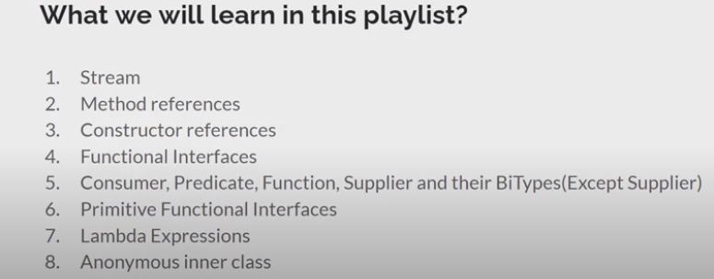

## Anonymous inner class:

Assume we have iprintable interface with print() method. We can use anonymous inner class like below.

(But we can use this only if interface implementation is not used across other classes and only sole purpose is to override it.)

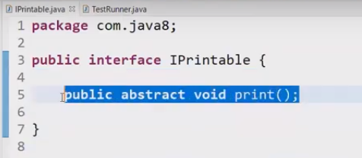

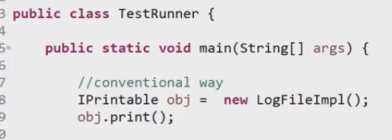

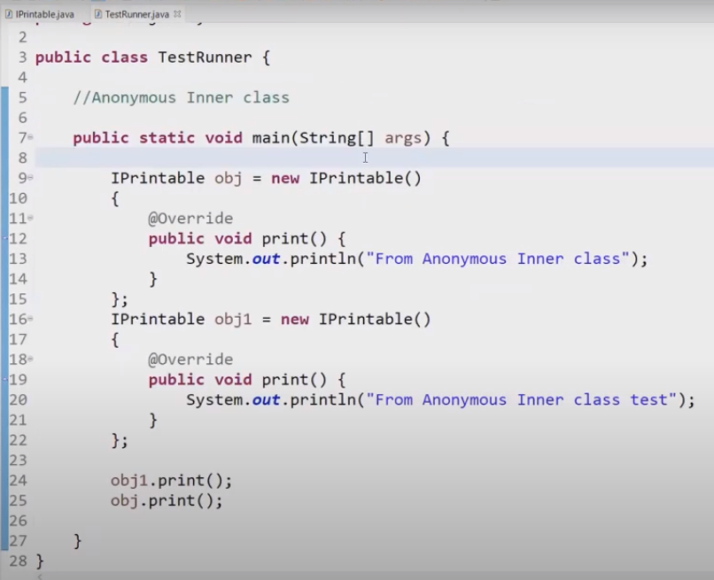

## Lambda expression:

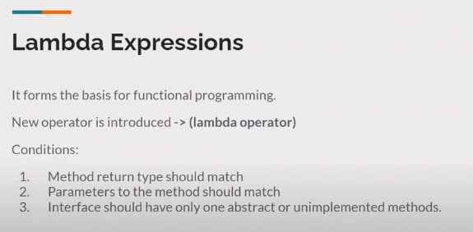

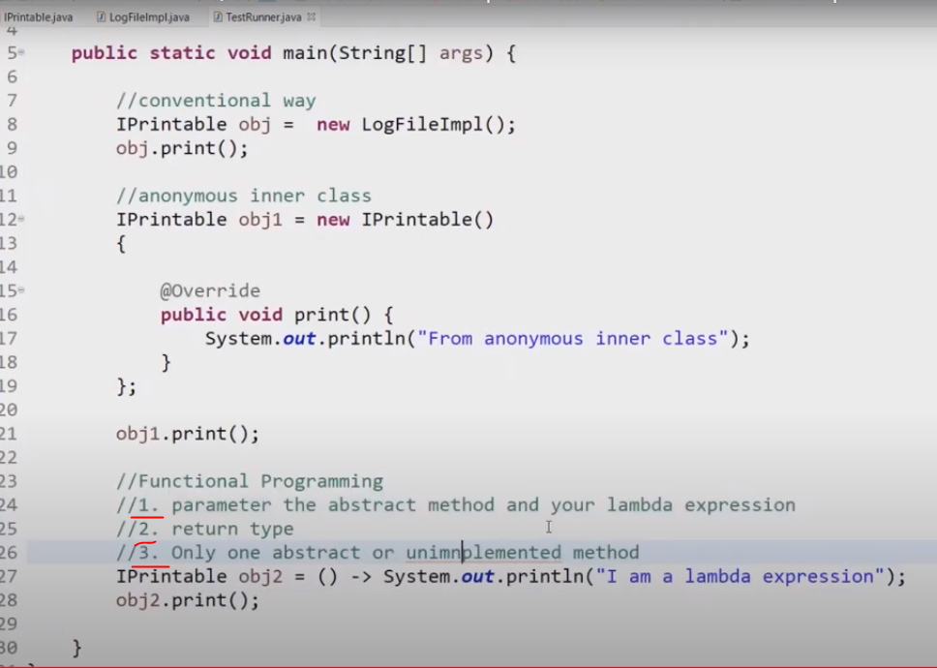

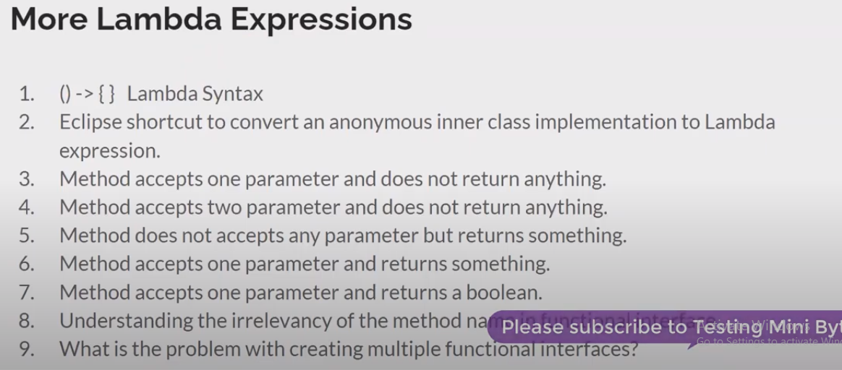

## Functional interface: Contains only one abstract method. Can have other static and default methods.

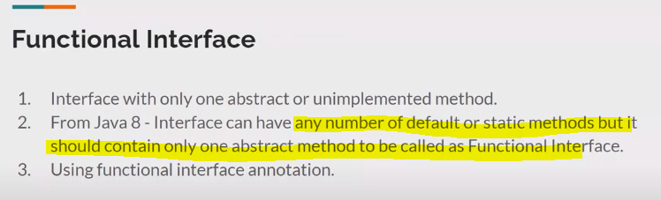

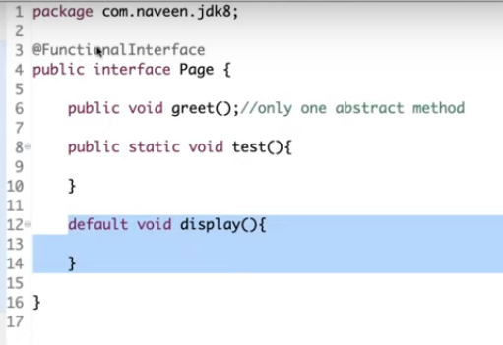

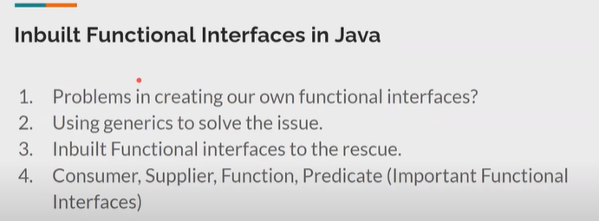

Here T can be any data type.

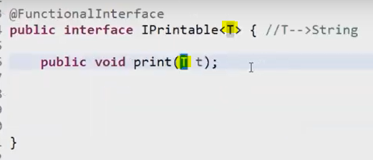

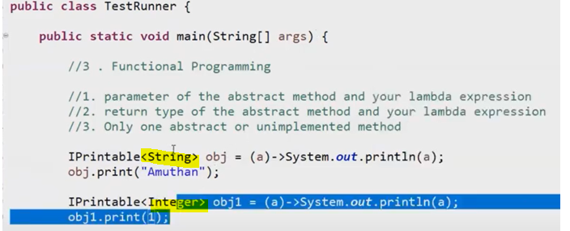

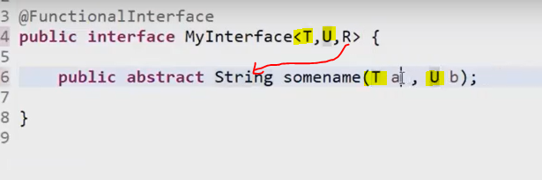

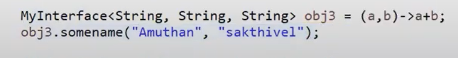

SO WE cannot create interfaces with all combinations.

That’s why java.util.function packages contains lot of functional interfaces readily.

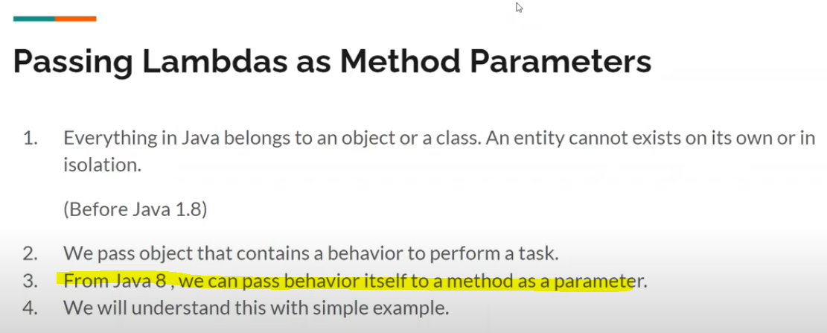

## 6 functional interfaces:

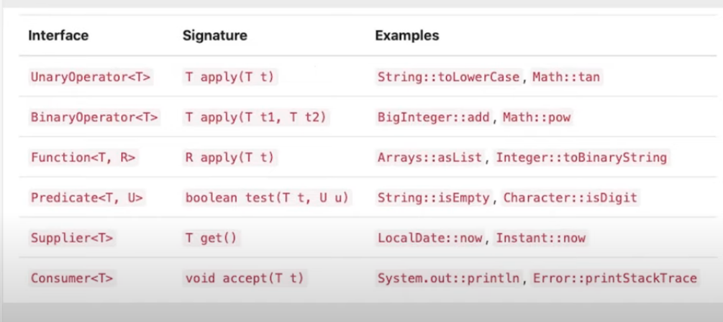

### What are the various categories of pre-defined function interfaces?

Function: To transform arguments in returnable value.

Predicate: To perform a test and return a Boolean value.

Consumer: Accept arguments but do not return any values. Supplier: Do not accept any arguments but return a value.

Operator: Perform a reduction type operation that accepts the same input types.

Application of Apply:

Type Parameters:

T - the type of the input to the function

R - the type of the result of the function

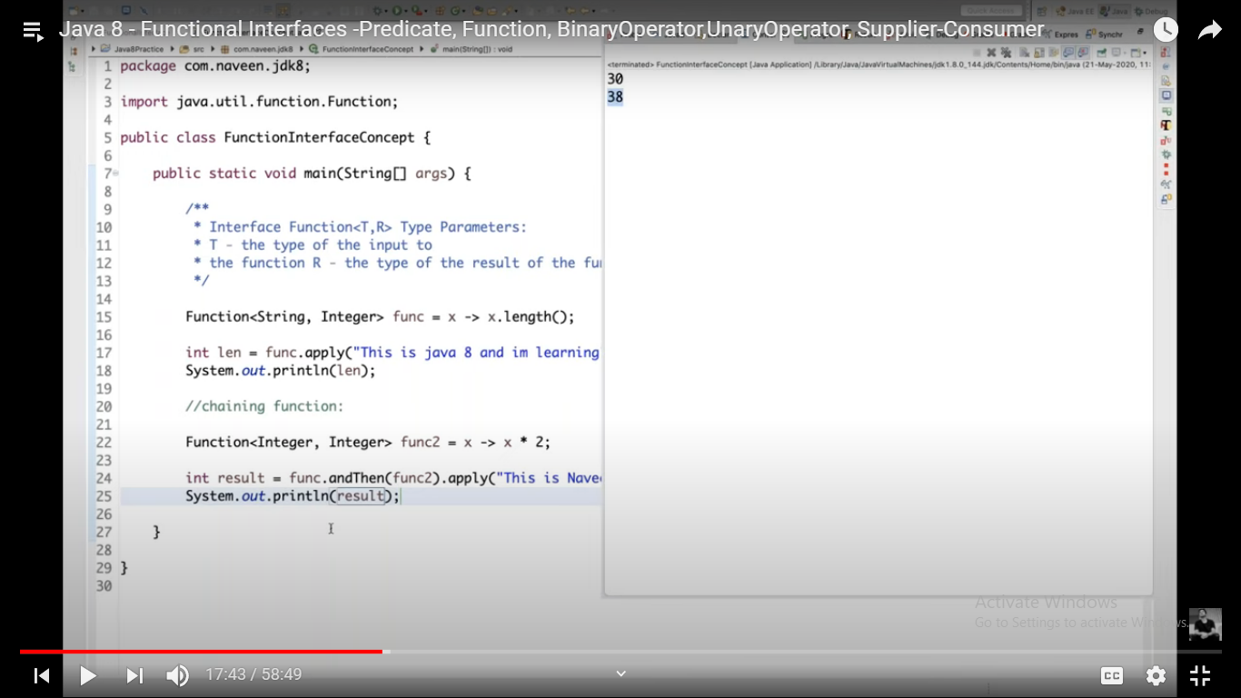

### BinaryOperator: **the operands and the result are all of the same type.**

Represents an operation **upon two operands** of the same type, producing a result of the same type as the operands. This is a specialization of [BiFunction](https://devdocs.io/openjdk~8/java/util/function/bifunction) for the case where **the operands and the result are all of the same type.**

**Ex:** BiFunction<Integer,Integer,Integer> is same as **BinaryOperator<Integer>**

[BiFunction](https://devdocs.io/openjdk~8/java/util/function/bifunction)<T,T,T>:we have to pass 3 arguments

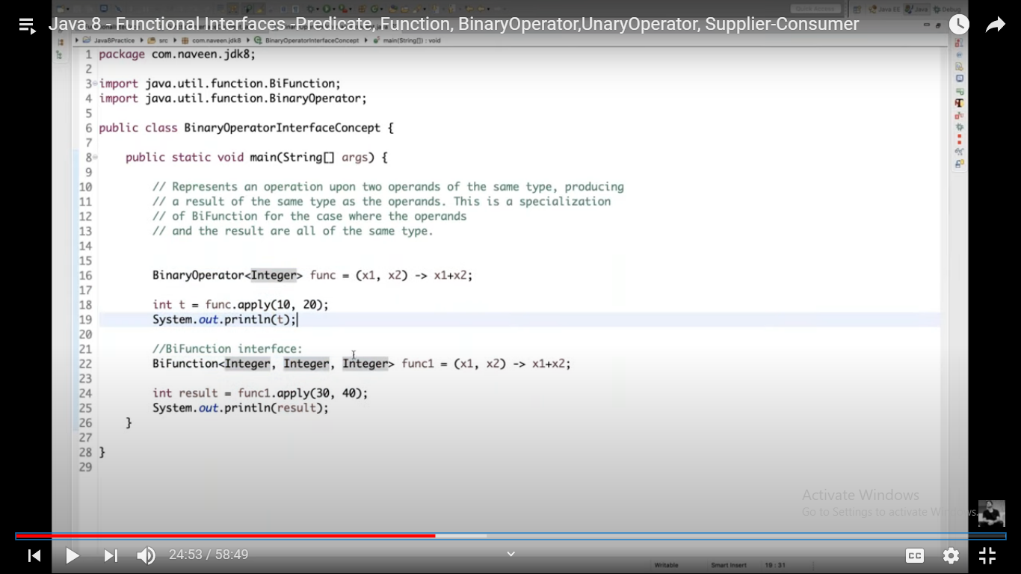

### Unary operator: **the operand and result are of the same type.**

Represents an operation on **a single operand/argument** that produces a result of the **same type as its operand**. This is a specialization of Function for the case **where the operand and result are of the same type.**

**Ex:** Function<**String**,**String**> == Unary Operator<**String**>

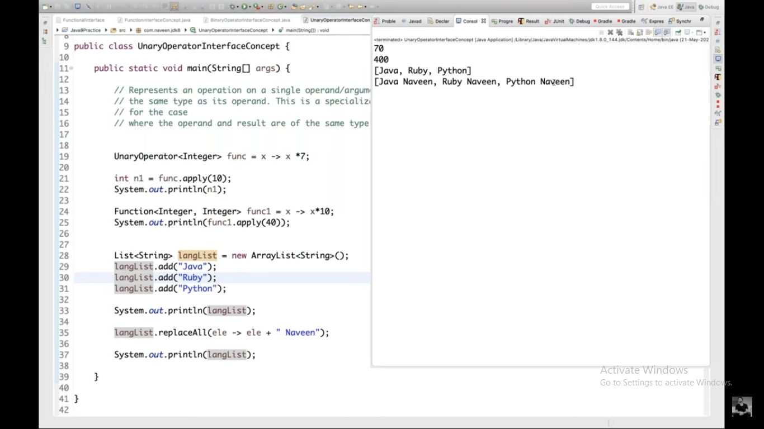

replaceAll()->takes unary operator as argument.

### Predicate Interface concept: **Represents a predicate (boolean-valued function) of one argument.**

This is a [functional interface](https://devdocs.io/openjdk~8/java/util/function/package-summary) whose functional method is [test(Object)](https://devdocs.io/openjdk~8/java/util/function/predicate#test-T-).

We can use **and, or, negate** operators

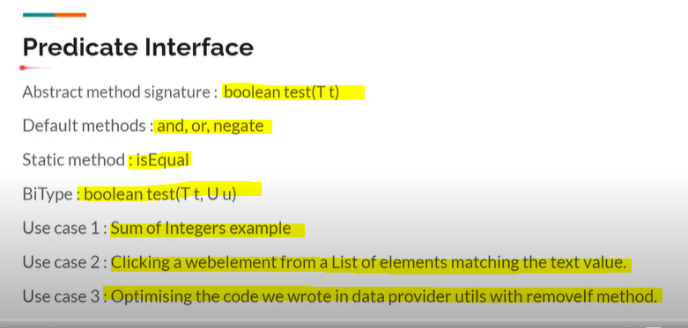

|  |  |
| --- | --- |
| **Modifier and Type** | **Method and Description** |
| default [Predicate](https://devdocs.io/openjdk~8/java/util/function/predicate)<[T](https://devdocs.io/openjdk~8/java/util/function/predicate)> | [and](https://devdocs.io/openjdk~8/java/util/function/predicate#and-java.util.function.Predicate-)([Predicate](https://devdocs.io/openjdk~8/java/util/function/predicate)<? super [T](https://devdocs.io/openjdk~8/java/util/function/predicate)> other)  Returns a composed predicate that represents a short-circuiting logical AND of this predicate and another. |
| static <T> [Predicate](https://devdocs.io/openjdk~8/java/util/function/predicate)<T> | [isEqual](https://devdocs.io/openjdk~8/java/util/function/predicate#isEqual-java.lang.Object-)([Object](https://devdocs.io/openjdk~8/java/lang/object) targetRef)  Returns a predicate that tests if two arguments are equal according to [Objects.equals(Object, Object)](https://devdocs.io/openjdk~8/java/util/objects" \l "equals-java.lang.Object-java.lang.Object-). |
| default [Predicate](https://devdocs.io/openjdk~8/java/util/function/predicate)<[T](https://devdocs.io/openjdk~8/java/util/function/predicate)> | [negate](https://devdocs.io/openjdk~8/java/util/function/predicate#negate--)()  Returns a predicate that represents the logical negation of this predicate. |
| default [Predicate](https://devdocs.io/openjdk~8/java/util/function/predicate)<[T](https://devdocs.io/openjdk~8/java/util/function/predicate)> | [or](https://devdocs.io/openjdk~8/java/util/function/predicate#or-java.util.function.Predicate-)([Predicate](https://devdocs.io/openjdk~8/java/util/function/predicate)<? super [T](https://devdocs.io/openjdk~8/java/util/function/predicate)> other)  Returns a composed predicate that represents a short-circuiting logical OR of this predicate and another. |
| boolean | [test](https://devdocs.io/openjdk~8/java/util/function/predicate#test-T-)([T](https://devdocs.io/openjdk~8/java/util/function/predicate) t)  Evaluates this predicate on the given argument. |

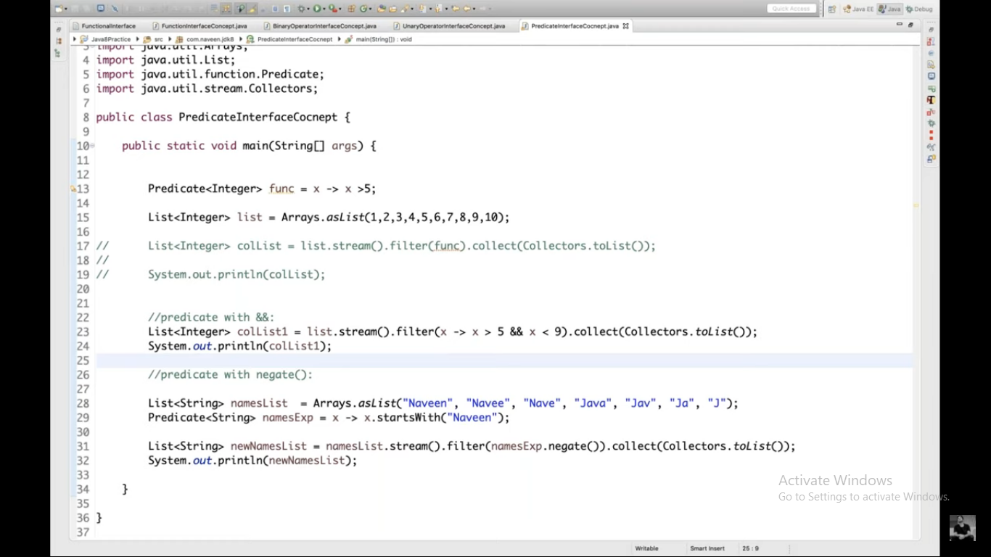

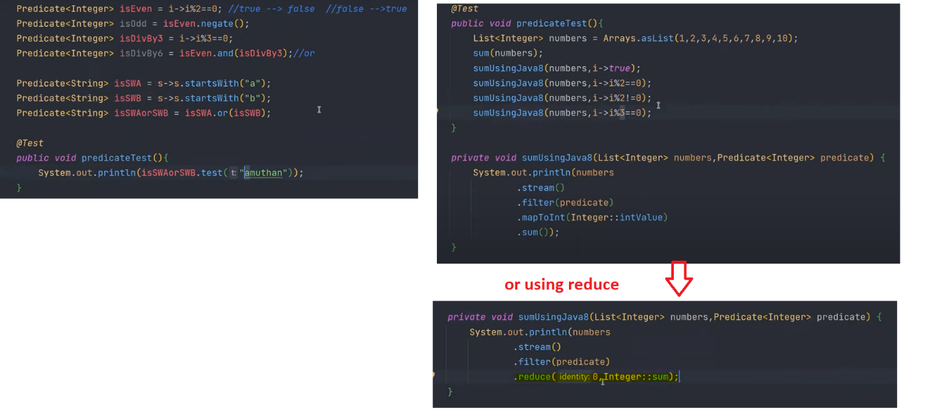

### BiPredicate<T,U>:**Represents a predicate (boolean-valued function) of two arguments.**

T - the type of the first argument to the predicate

U - the type of the second argument the predicate

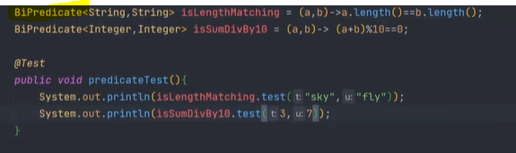

### Consumer: accepts **a single input argument** and **returns no result**

Represents an operation that accepts **a single input argument** and **returns no result**. Unlike most other functional interfaces, Consumer is expected to operate via side-effects.

All Known Subinterfaces:

[Stream.Builder](https://devdocs.io/openjdk~8/java/util/stream/stream.builder)<T>

This is a [functional interface](https://devdocs.io/openjdk~8/java/util/function/package-summary) whose functional method is [accept(Object)](https://devdocs.io/openjdk~8/java/util/function/consumer#accept-T-).

Here forEach is a consumer type interface.

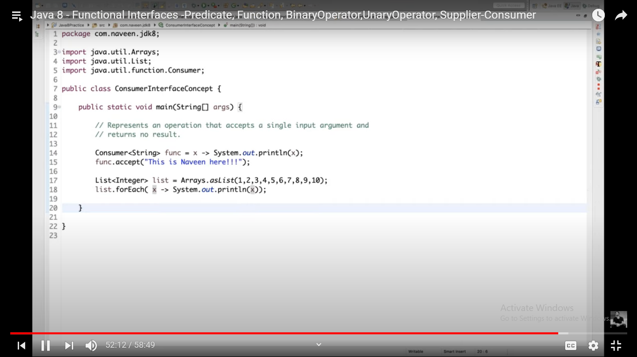

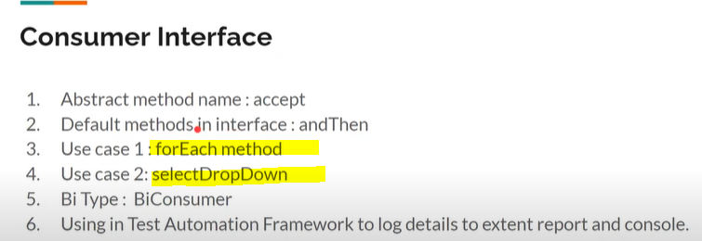

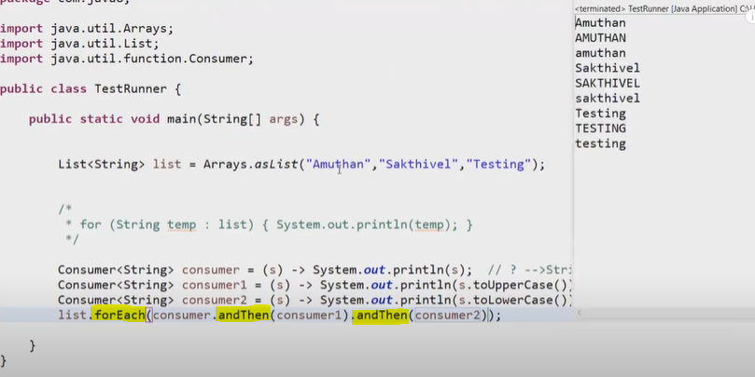

Automation use case:

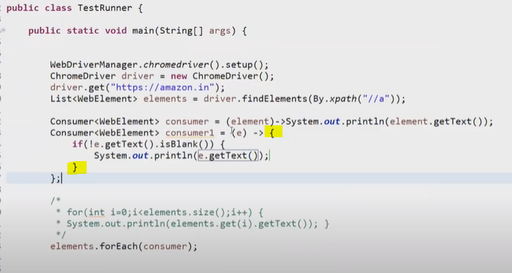

Handling Drowdown with consumer:

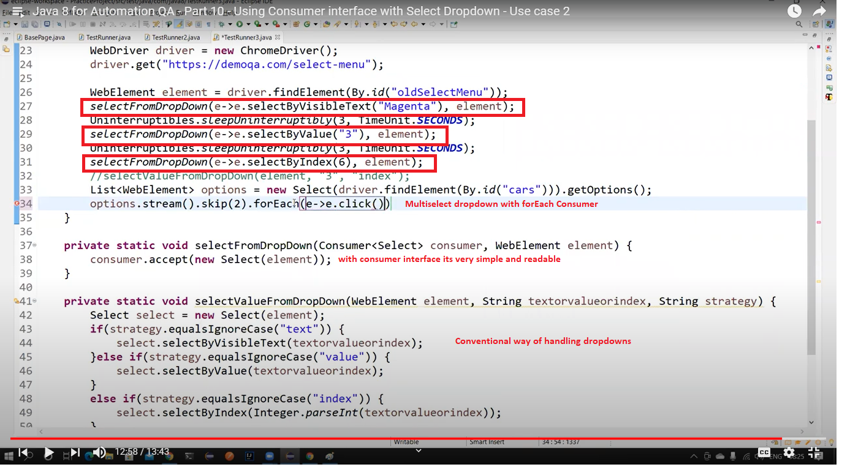

And another practical example of extend report logging is explained with consumer.

<https://www.youtube.com/watch?v=yeO87WAmaDY&list=PL9ok7C7Yn9A_o6wKmhObLceifmpoQ9QNp&index=11>

### BiConsumer<T,U> : **accepts two input arguments and returns no result**

Represents an operation that **accepts two input arguments and returns no result**. This is the two-arity specialization of [Consumer](https://devdocs.io/openjdk~8/java/util/function/consumer). Unlike most other functional interfaces, BiConsumer is expected to operate via side-effects.

This is a [functional interface](https://devdocs.io/openjdk~8/java/util/function/package-summary) whose functional method is [accept(Object, Object)](https://devdocs.io/openjdk~8/java/util/function/biconsumer#accept-T-U-).

Usecase: Reading properties from .prop file

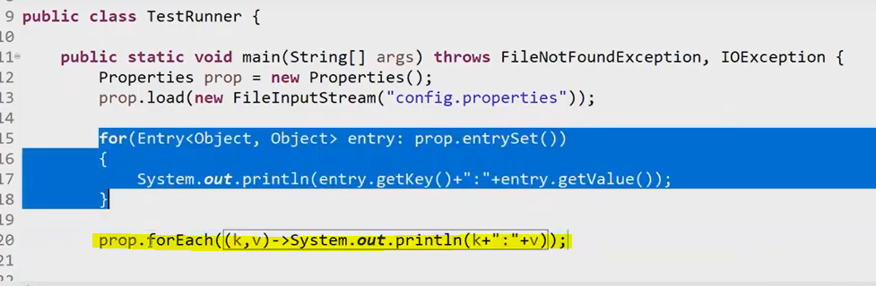

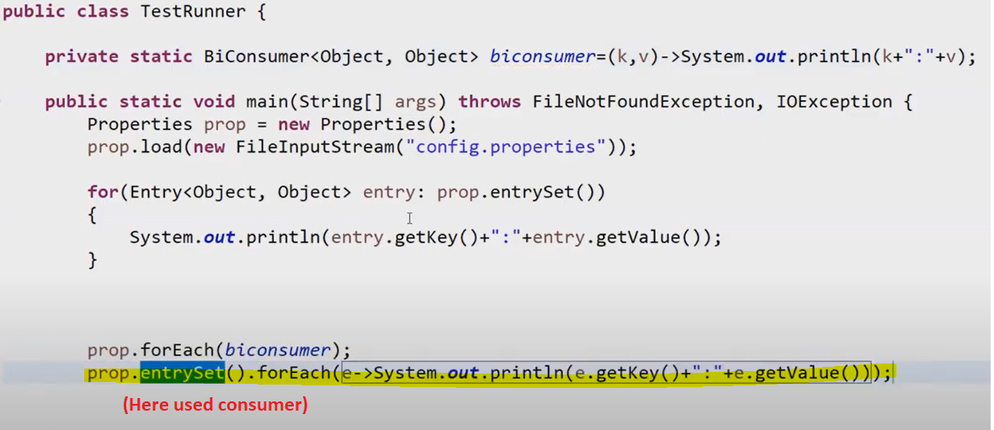

We can use biconsumer in case of map.

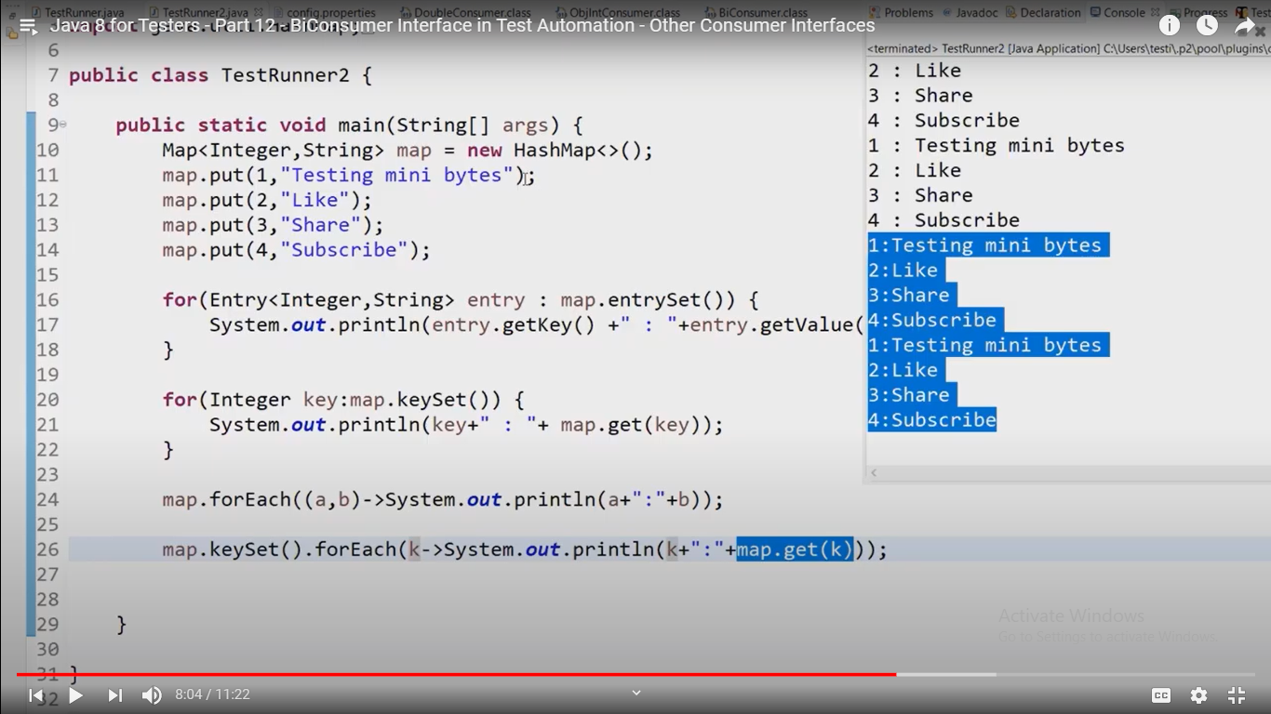

### Other consumer interfaces:

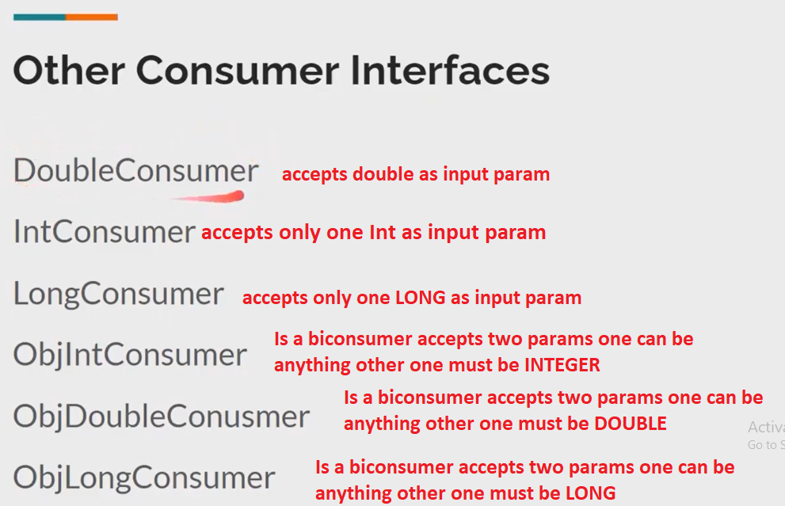

### Supplier<T>: **Will not take any argument but returns a result.**

Represents a supplier of results.

There is no requirement that a new or distinct result be returned each time the supplier is invoked.

This is a [functional interface](https://devdocs.io/openjdk~8/java/util/function/package-summary) whose functional **method is**[**get()**](https://devdocs.io/openjdk~8/java/util/function/supplier#get--)**.**

Interface Supplier<T>

Type Parameters:

T - the type of results supplied by this supplier

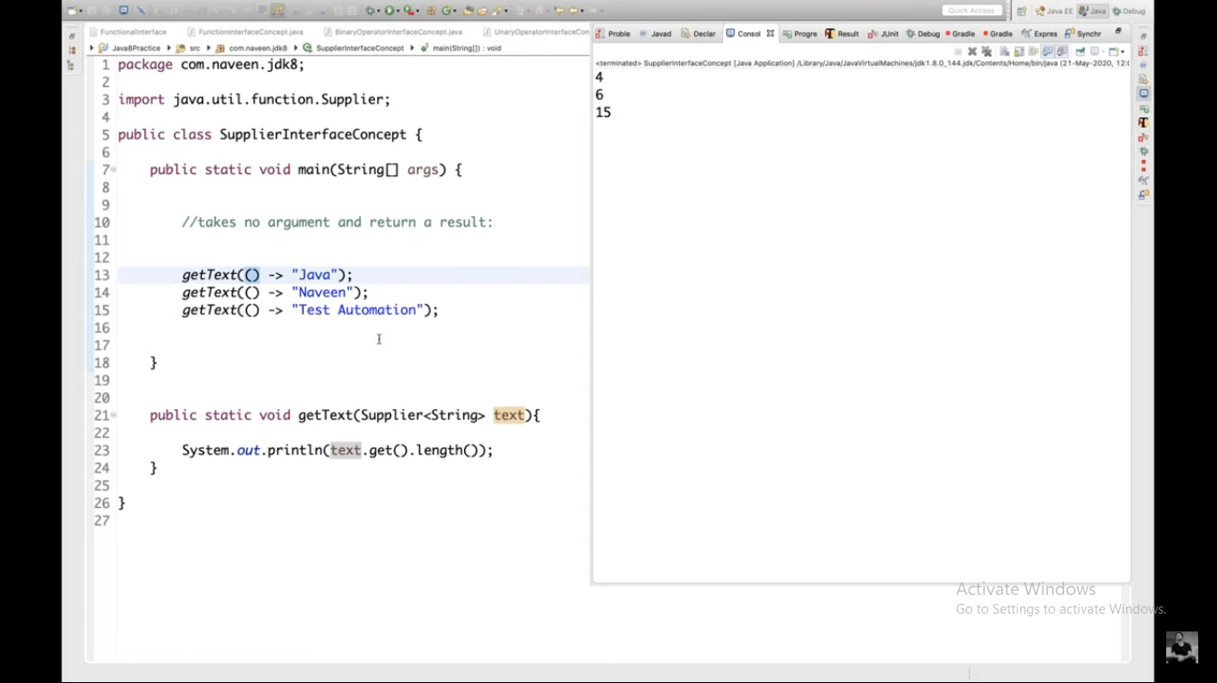

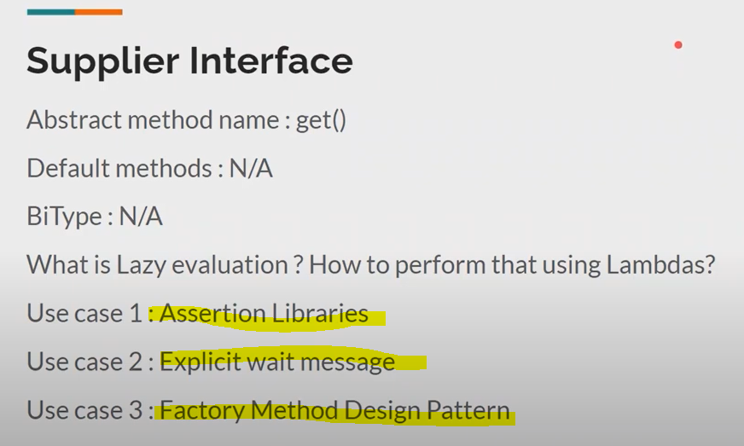

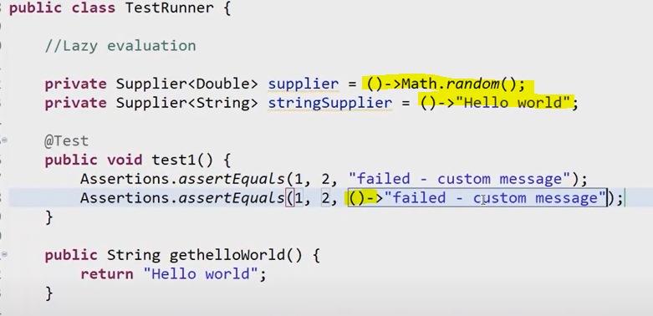

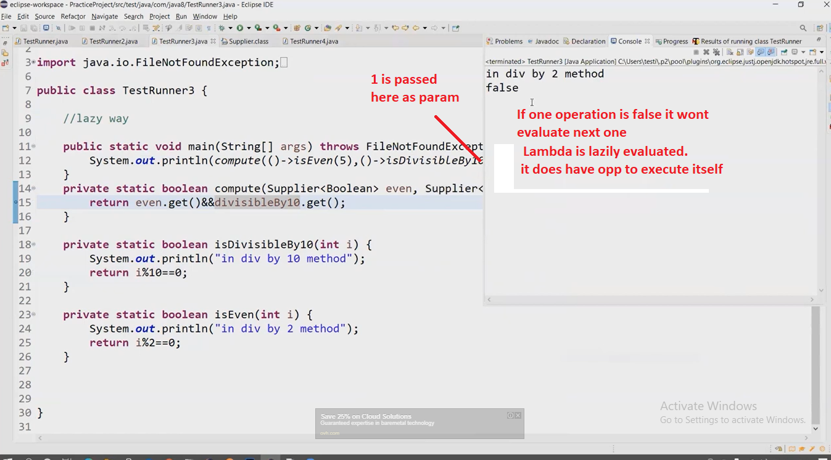

Use case in explicit wait:

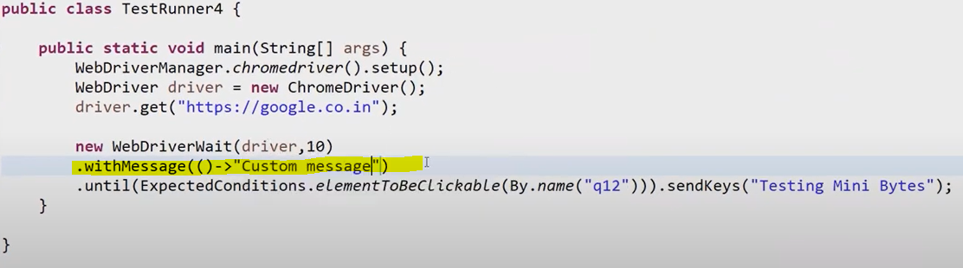

Factory design usecase:

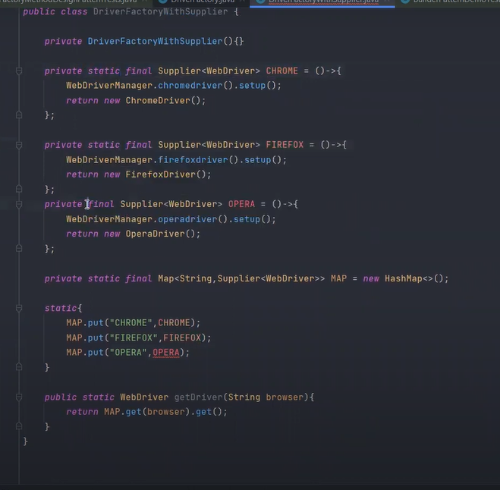

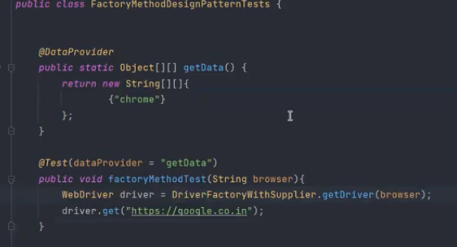

### Interface Function<T,R>:**accepts one argument and produces a result**.

Type Parameters:

T - the type of the input to the function

R - the type of the result of the function

This is a [functional interface](https://devdocs.io/openjdk~8/java/util/function/package-summary) whose functional method is [apply(Object)](https://devdocs.io/openjdk~8/java/util/function/function#apply-T-).

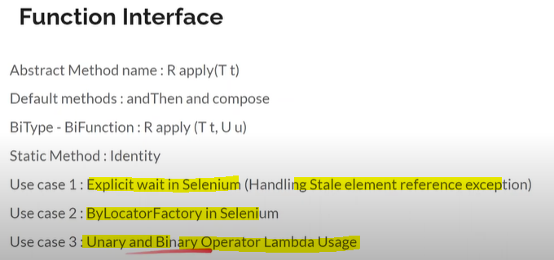

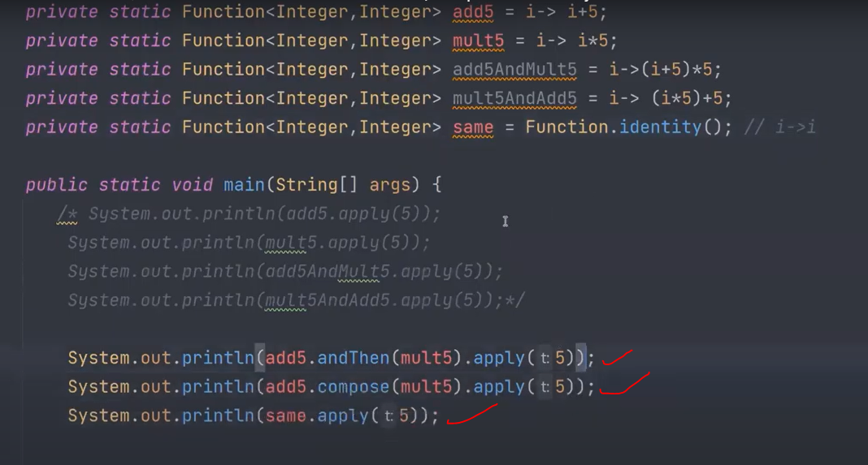

We can chain also. But op type of first function should be same as input type of second function.

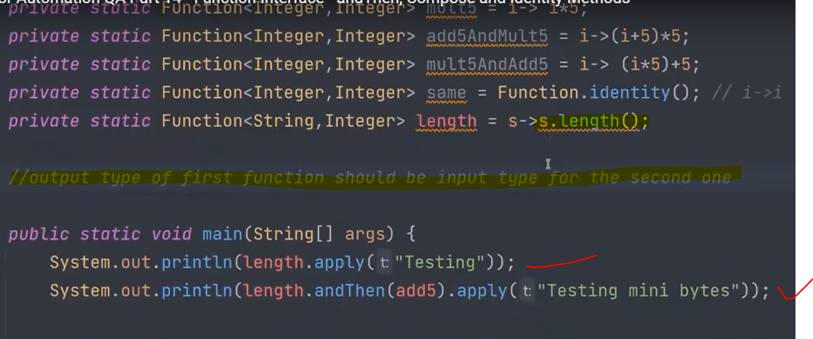

### Interface BiFunction<T,U,R>: **accepts two arguments and produces a result. This is the two-arity specialization of Function.**

Note: *BiFunciton<Integer,Integer,Integer> is same as BiFunction<Integer>*

Type Parameters:

T - the type of the first argument to the function

U - the type of the second argument to the function

R - the type of the result of the function

It has only AndThen Method.

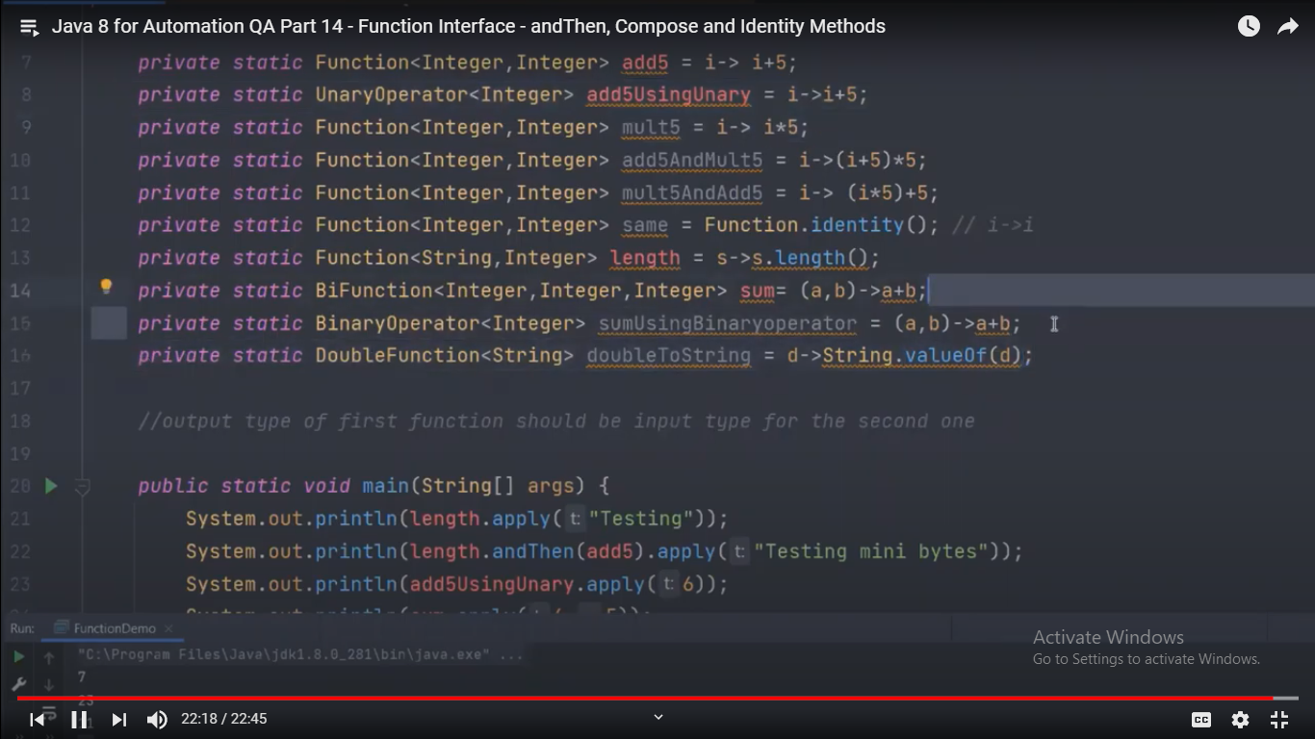

Stale element exception:

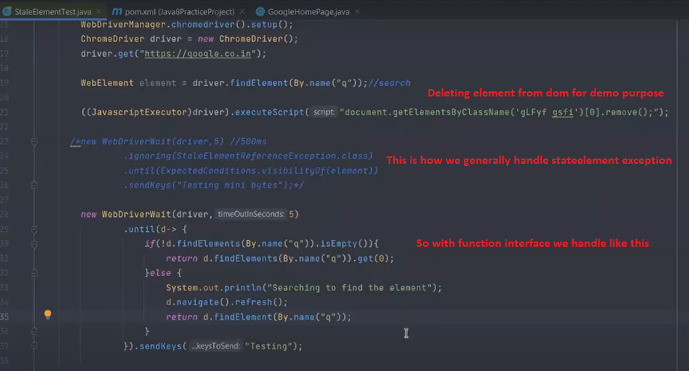

Replaceall ,Reduce methods:

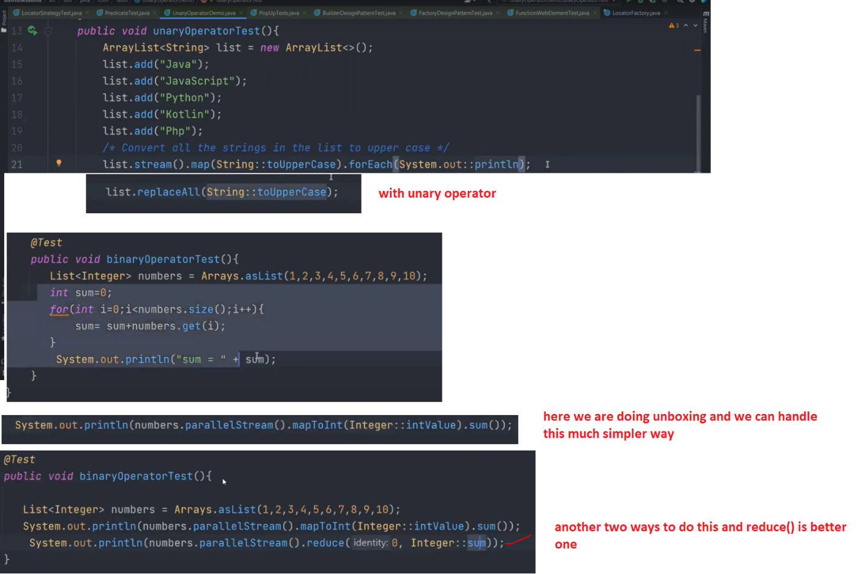

### Iterable:

Performs the given action for each element of the Iterable until all elements have been processed or the action throws an exception. Unless otherwise specified by the implementing class, actions are performed in the order of iteration (if an iteration order is specified). Exceptions thrown by the action are relayed to the caller.

**Note:For each always takes a consumer interface**

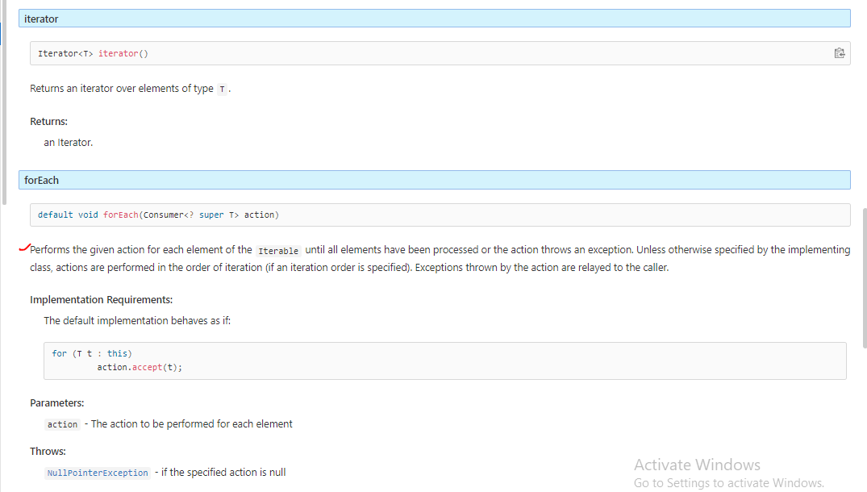

Lambda expressions and Method references example:

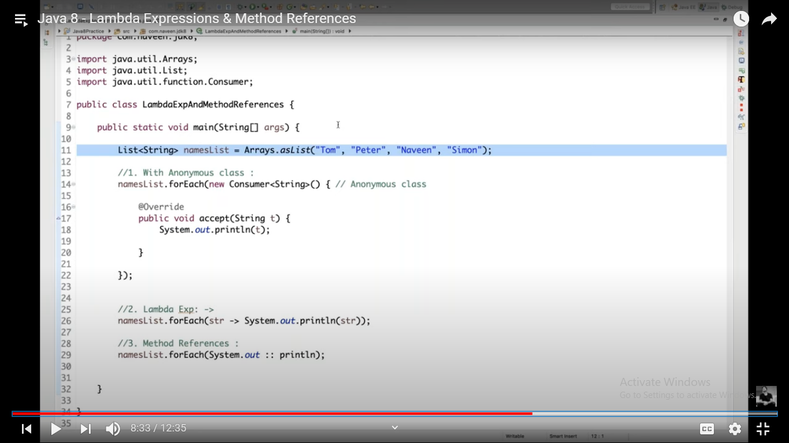

# Java 8 Usecases in selenium:

method reference is possible: when you recieve is what you sent

Higher order funciton: passing fuction to function

intermediatory operations: whihc do not make any modifications on list

final operation: whihc is going to get result

## Filter operations:

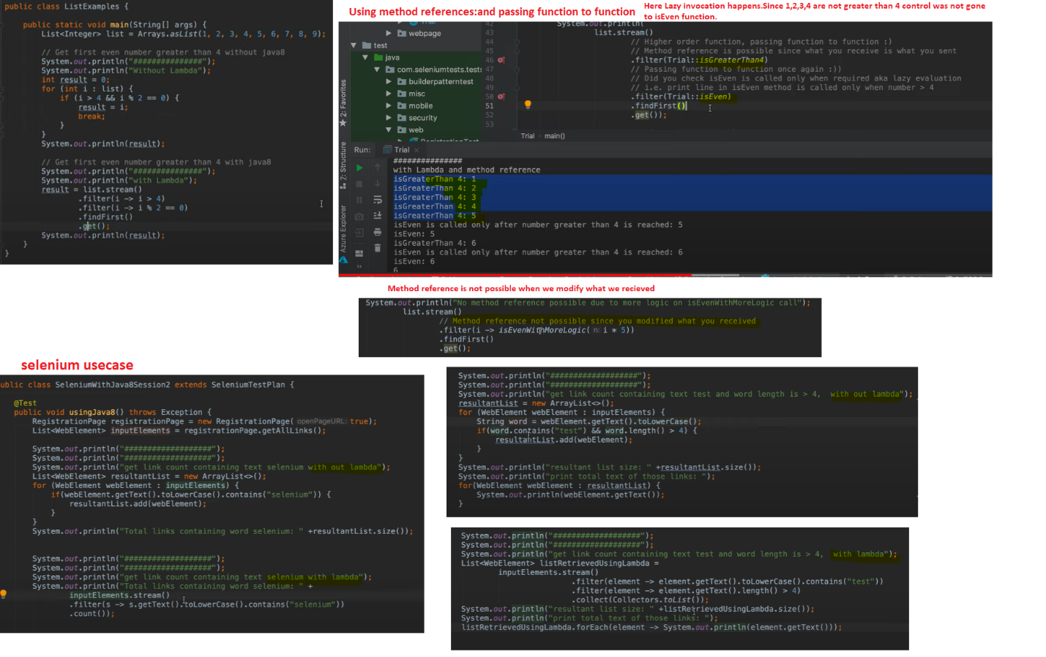

## Stream map operations and Selenium WebDriver:

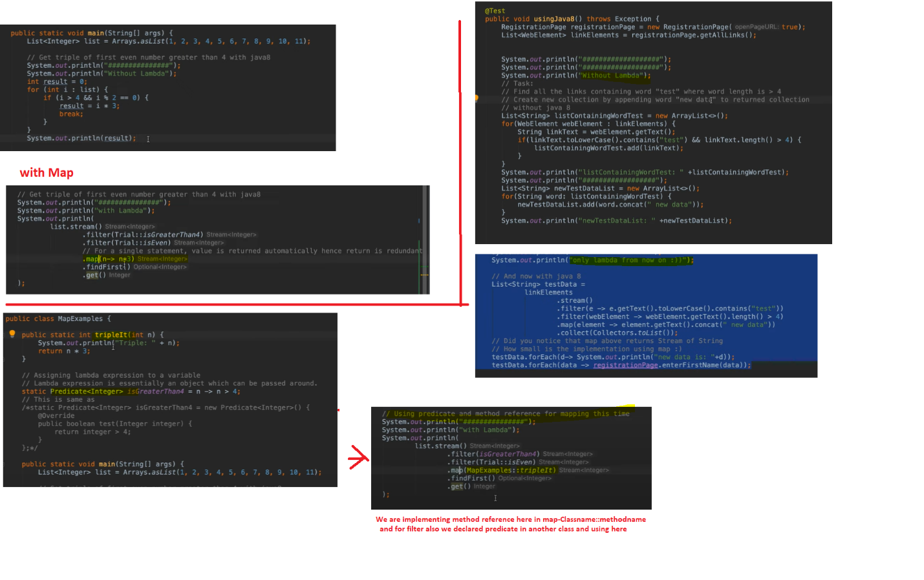

## Optional and Selenium WebDriver: **A container object which may or may not contain a non-null value**

<https://devdocs.io/openjdk~8/java/util/optional> explains in detail.Go through it

ifPresent(Consumer<? super T> consumer) returntype: void

If a value is present, invoke the specified consumer with the value, otherwise do nothing.

isPresent() returntype: boolean

Return true if there is a value present, otherwise false.

orElse(T other) returntype: [T](https://devdocs.io/openjdk~8/java/util/optional)

Return the value if present, otherwise return other.

ofNullable(T value) returntype: static <T> [Optional](https://devdocs.io/openjdk~8/java/util/optional)<T>

Returns an Optional describing the specified value, if non-null, otherwise returns an empty Optional.

get() Returntype: [T](https://devdocs.io/openjdk~8/java/util/optional)

If a value is present in this Optional, returns the value, otherwise throws NoSuchElementException.

orElseThrow(Supplier<? extends X> exceptionSupplier)

Return the contained value, if present, otherwise throw an exception to be created by the provided supplier.

map(Function<? super T,? extends U> mapper)

If a value is present, apply the provided mapping function to it, and if the result is non-null, return an Optional describing the result.

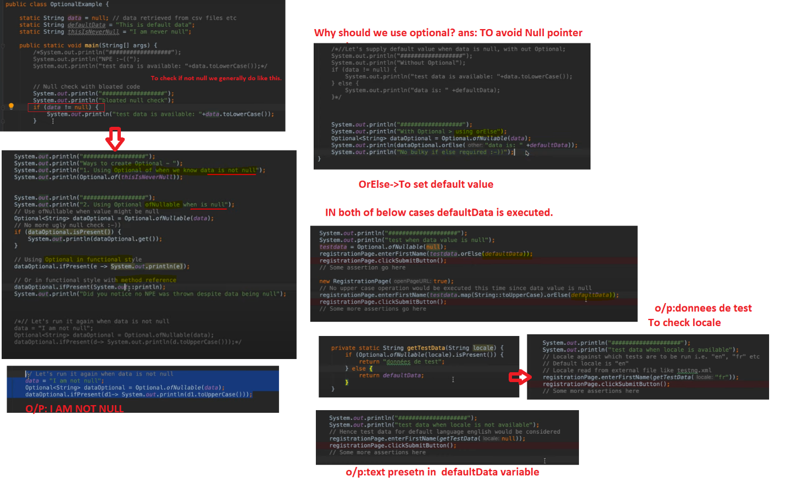

## Optimising getText, getTagName, getAttribute methods in Selenium:

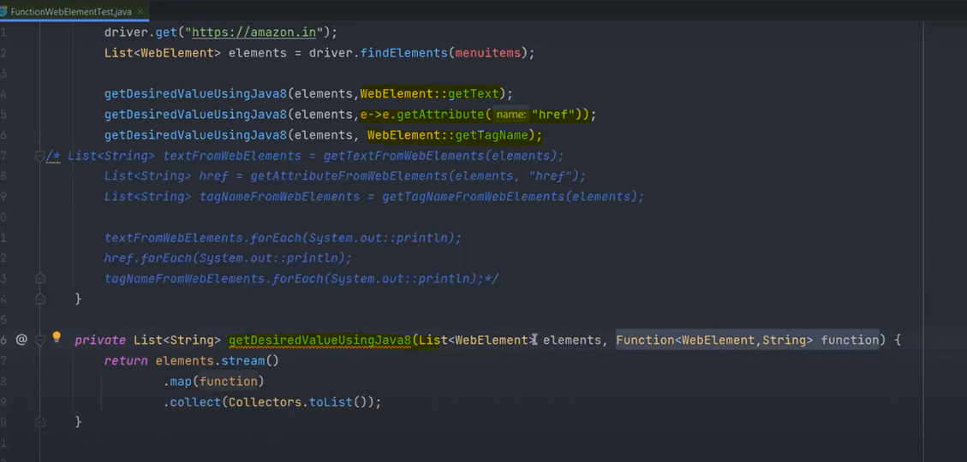

### Click a Web Element among list of Elements when Text matches:**Predicate interface**

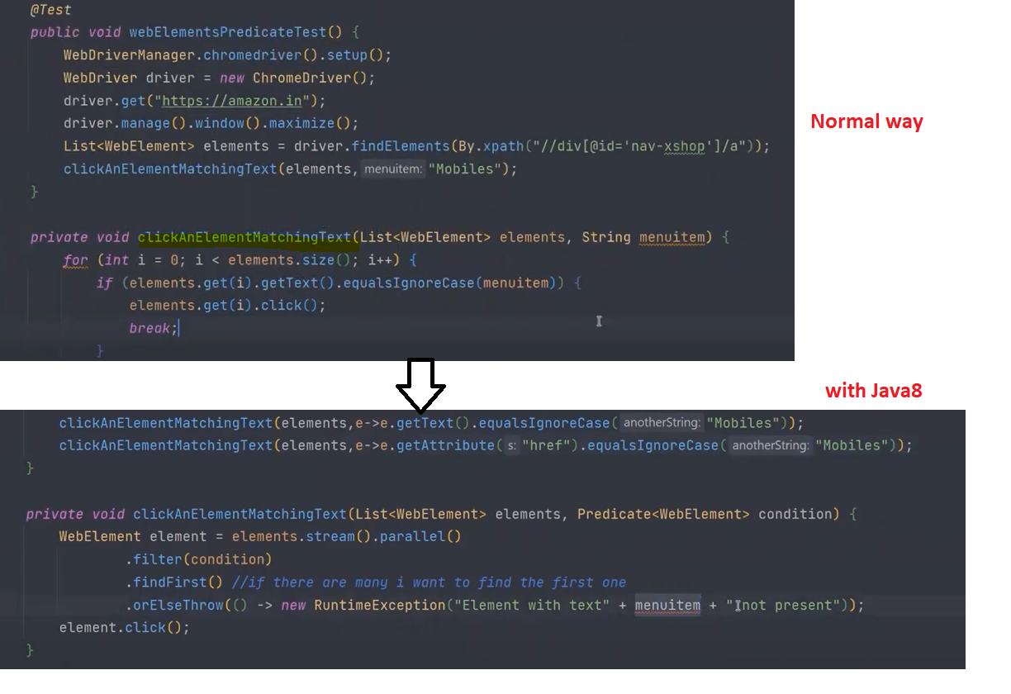

# API Streams:

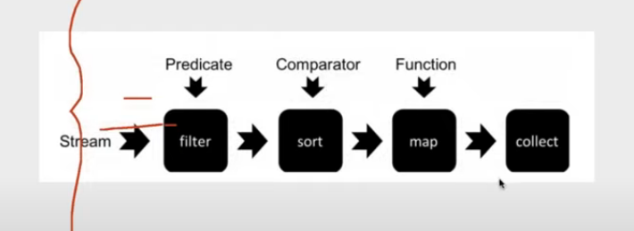

Examples:

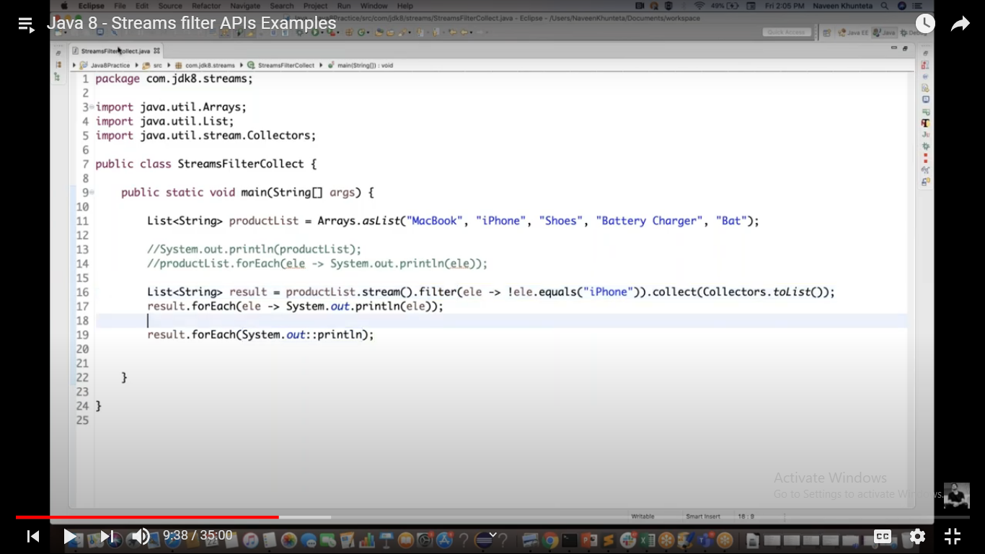

Find any or Else:

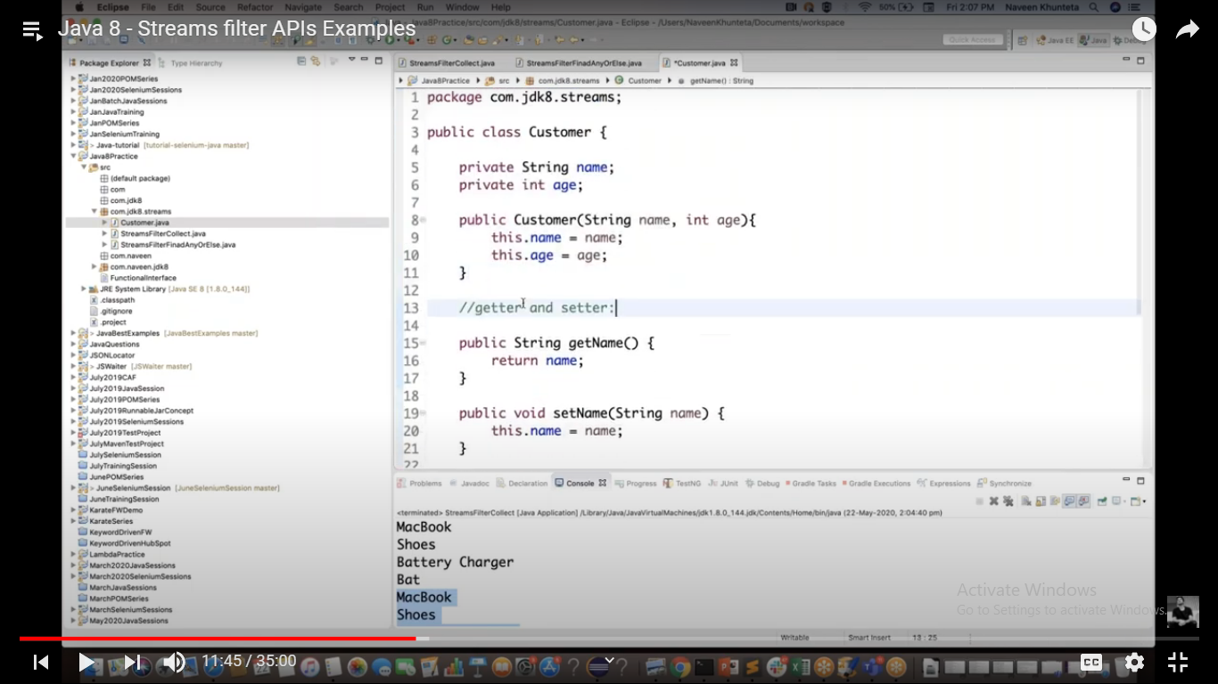

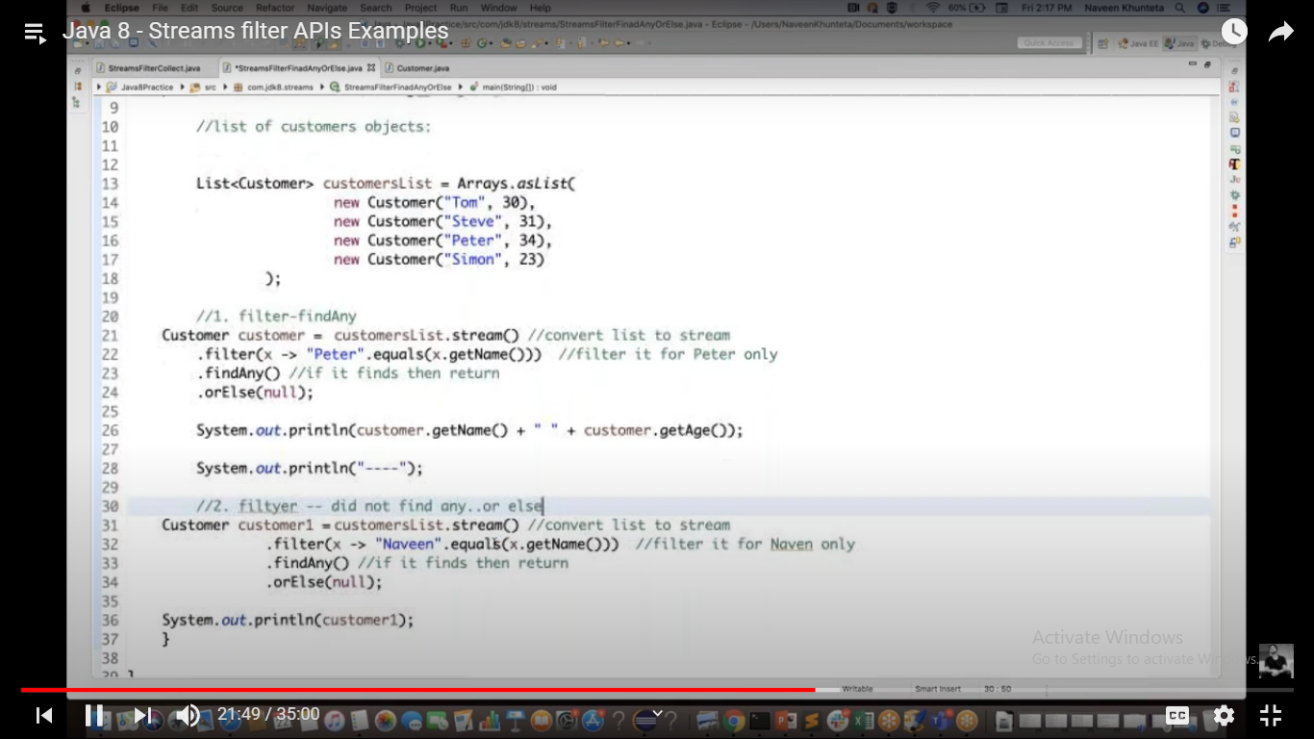

//3.with multiple conditions:

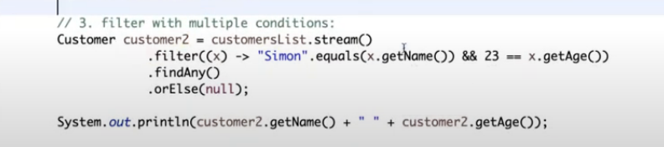

Map example:

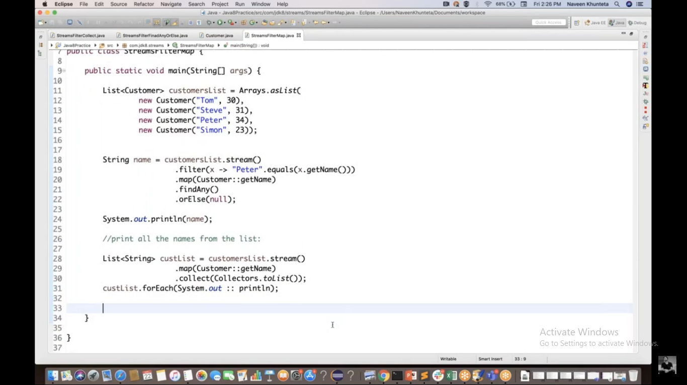

Generate Infinite Streams using iterate() and generate() methods:

Both are used to generate a stream, iterate() methods takes a seed and UnaryOperator to generate the stream of data. generate() method takes Supplier interface as an input to generate the stream of data.

<https://www.baeldung.com/java-8-streams>

### Empty Stream

We should use the **empty()** method in case of the creation of an empty stream:

Stream<String> streamEmpty = Stream.empty();

We often use the empty() method upon creation to avoid returning null for streams with no element:

### Stream of Collection

We can also create a stream of any type of Collection (Collection, List, Set):

Collection<String> collection = Arrays.asList("a", "b", "c");

Stream<String> streamOfCollection = collection.stream();

### Stream of Array

An array can also be the source of a stream:

Stream<String> streamOfArray = Stream.of("a", "b", "c");

We can also create a stream out of an existing array or of part of an array:

String[] arr = new String[]{"a", "b", "c"};

Stream<String> streamOfArrayFull = Arrays.stream(arr);

Stream<String> streamOfArrayPart = Arrays.stream(arr, 1, 3);

### Stream.builder()

When builder is used, the **desired type should be additionally specified** in the right part of the statement, otherwise the **build() method will create an instance of the Stream<Object>:**

Stream<String> streamBuilder = Stream.<String>builder().add("a").add("b").add("c").build()

### Stream.generate()

The generate() method **accepts a Supplier<T> for element** generation. As the resulting stream is infinite, the **developer should specify the desired size, or the** generate() method will work until it reaches the memory limit:

Stream<String> streamGenerated = Stream.generate(() -> "element").limit(10);

### Stream of Primitives

Java 8 offers the possibility to create streams out of three primitive types: int, long and double. As Stream<T> is a generic interface, and there is no way to use primitives as a type parameter with generics, **three new special interfaces** were created**: IntStream, LongStream, DoubleStream**.

Using the new interfaces alleviates unnecessary auto-boxing, which allows for increased productivity:

IntStream intStream = IntStream.**range**(1, 3);

//The range(int startInclusive, int endExclusive)

LongStream longStream = LongStream.**rangeClosed**(1, 3)

//The rangeClosed(int startInclusive, int endInclusive)

Since Java 8, the Random class provides a wide range of methods for generating streams of primitives. For example, the following code creates a DoubleStream, which has three elements:

Random random = **new** Random();

DoubleStream doubleStream = random.doubles(3);

### **Stream of**String:

We can also use String as a source for creating a stream with the help of the **chars()** method of the String class. Since there **is no interface for CharStream in JDK, we use the IntStream** to represent a stream of chars instead.

IntStream streamOfChars = "abc".chars();

### Note: **Java 8 streams can't be reused.**

This kind of behavior is logical. We designed streams to apply a finite sequence of operations to the source of elements in a functional style, not to store elements.

**We can only use one terminal operation per stream.**

**don't leave an instantiated stream unconsumed, as that will lead to memory leaks.**

### Lazy Invocation

Intermediate operations are lazy. This means that they will be invoked only if it is necessary for the terminal operation execution.

For example, let's call the method wasCalled(), which increments an inner counter every time it's called:

**private** **long** counter;

**private** **void** **wasCalled**()

{ counter++; }

Now let's call the method wasCalled() from operation filter():

List<String> list = Arrays.asList(“abc1”, “abc2”, “abc3”);

counter = 0;

Stream<String> stream = list.stream().filter(element -> { wasCalled();

**return** element.contains("2"); });

As we have a source of three elements, we can assume that the filter() method will be called three times, and the value of the counter variable will be 3. However, running this code doesn't change counter at all, it is still zero, so the filter() method wasn't even called once. The reason why is missing of the terminal operation.

Let's rewrite this code a little bit by adding a map() operation and a terminal operation, findFirst(). We will also add the ability to track the order of method calls with the help of logging:

Optional<String> stream = list.stream().filter(element ->

{ log.info("filter() was called");

**return** element.contains("2"); }).map(element -> {

log.info("map() was called");

**return** element.toUpperCase(); }).findFirst();

and **the right order is one of the most important aspects of chaining operations in the stream pipeline:**

**intermediate operations which reduce the size of the stream should be placed before operations which are applying to each element.** So we need to keep methods such as **skip(), filter(), and distinct()** at the top of our stream pipeline.

### Parallel stream:

The API allows us to create parallel streams, which perform operations in a parallel mode. When the source of a stream is a Collection or an array, it can be achieved with the help of the **parallelStream()** method:

Stream<Product> streamOfCollection = productList.parallelStream();

**boolean** isParallel = streamOfCollection.isParallel();

**boolean** bigPrice = streamOfCollection .map(product -> product.getPrice() * 12) .anyMatch(price -> price > 200);

If the source of a stream is **something other than a Collection or an array, the parallel()** method should be used:

IntStream intStreamParallel = IntStream.range(1, 150).parallel();

**boolean** isParallel = intStreamParallel.isParallel();

When using streams in parallel mode**, avoid blocking operations**. It is also best to use parallel mode when tasks need a similar amount of time to execute. If one task lasts much longer than the other, it can slow down the complete app’s workflow

The stream in parallel mode can be converted back to the sequential mode by using the **sequential()** method

IntStream intStreamSequential = intStreamParallel.sequential();

**boolean** isParallel = intStreamSequential.isParallel();

# JDK 12: New switch case

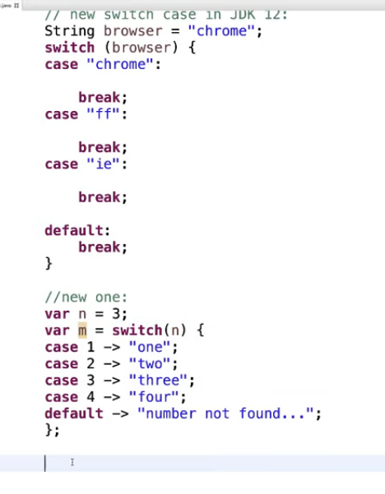

# JDK13:

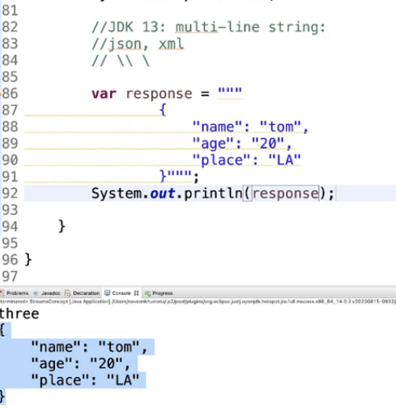

# JDK 14:Record keyword

No need to create constructor,getter,setter methods.record will take of all these

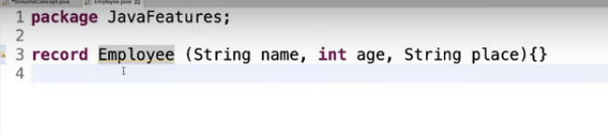

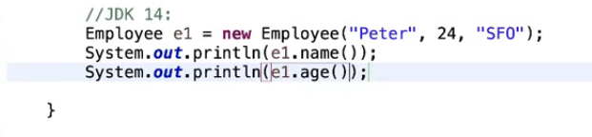

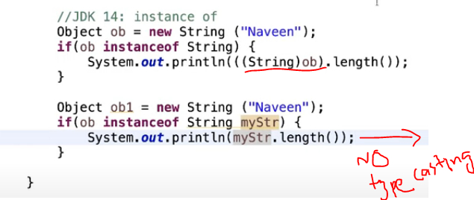

# Optional class in JDK 8:

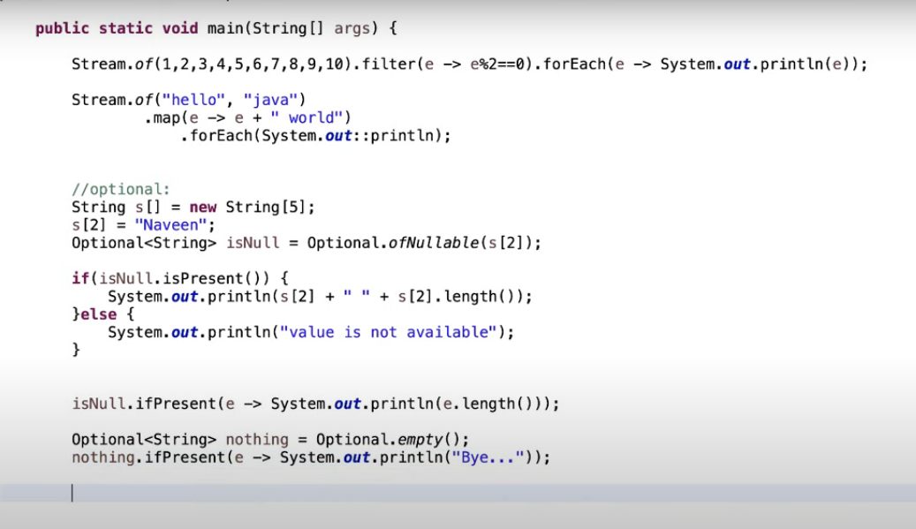

Dynamic polymorphism with data members is not allowed:

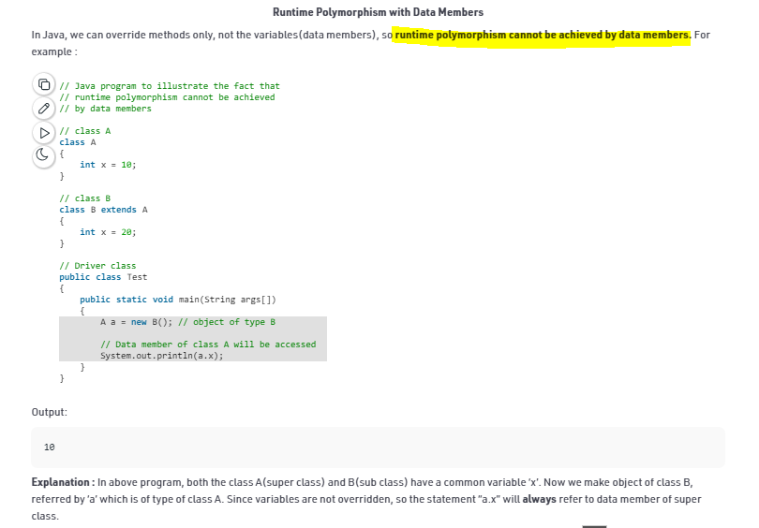

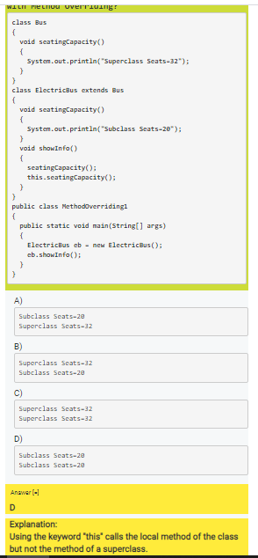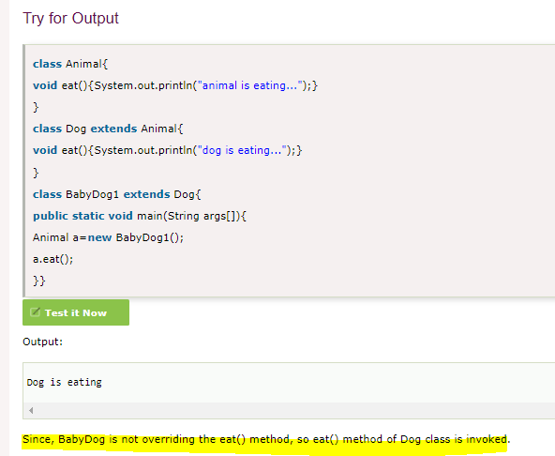

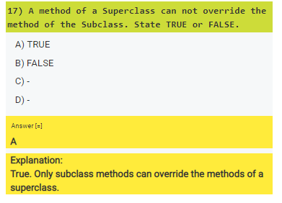

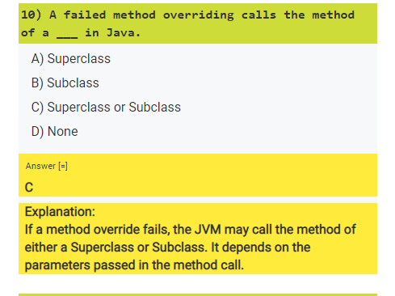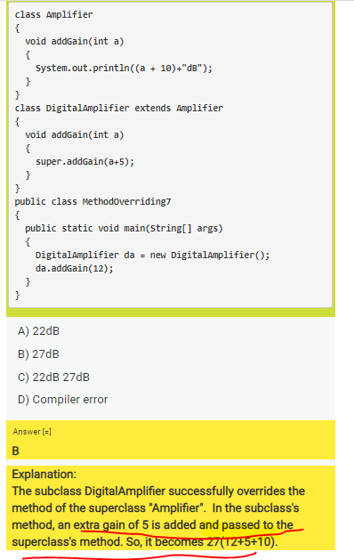

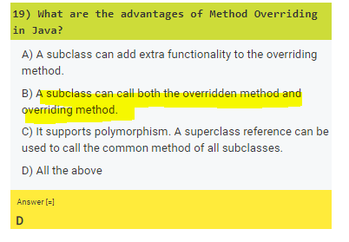

# Core java basic concepts-Written notes

Memory management:

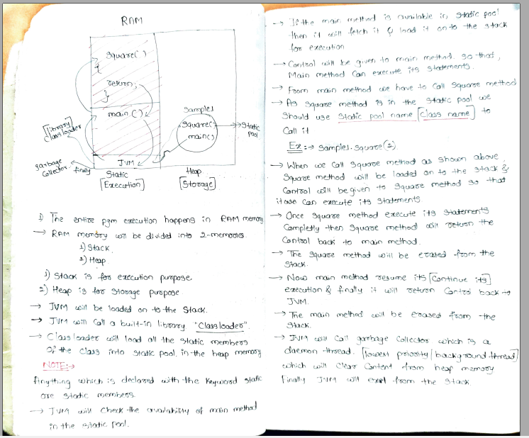

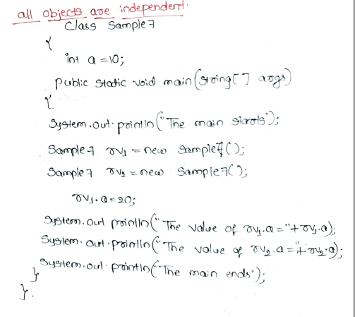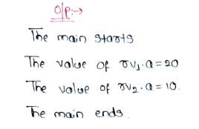

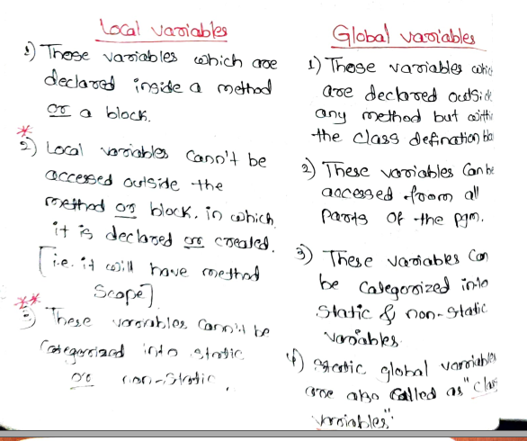

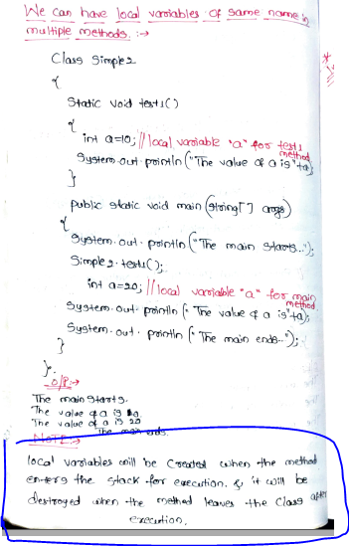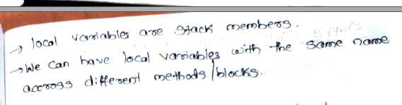

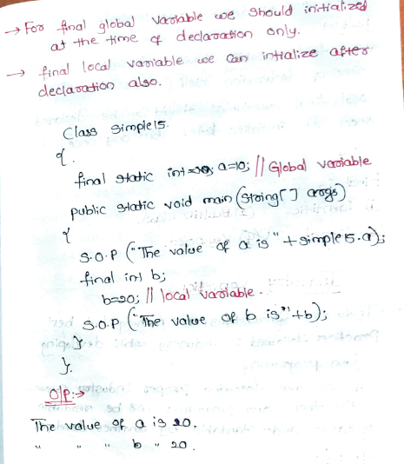

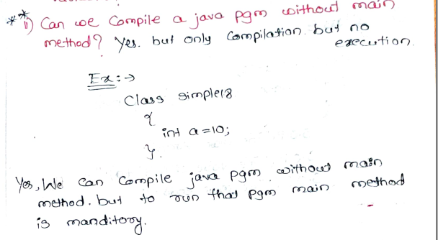

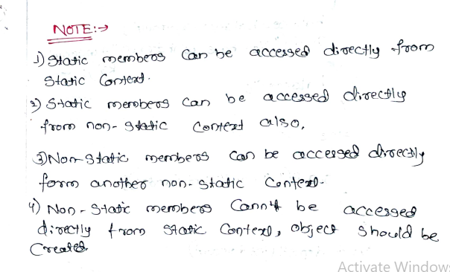

It is not a constructor because it has return type as void.

In general constructor cannot have return type.

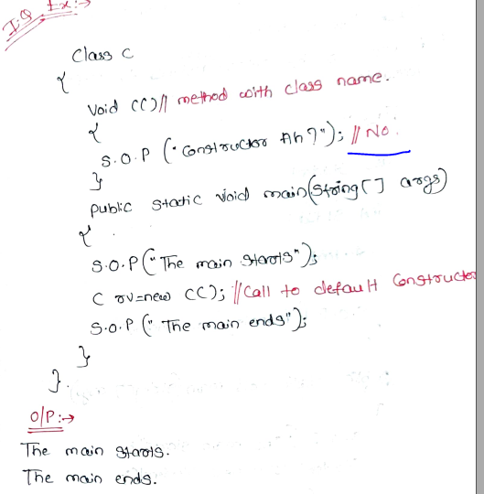

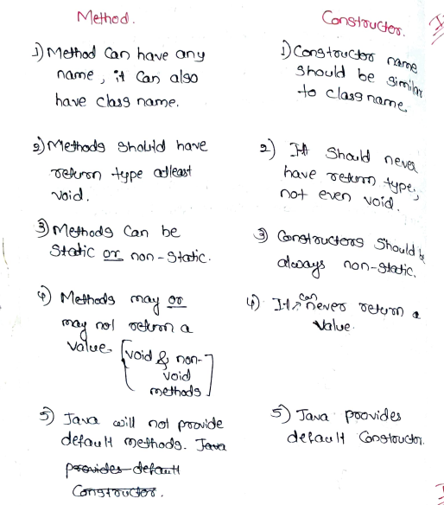

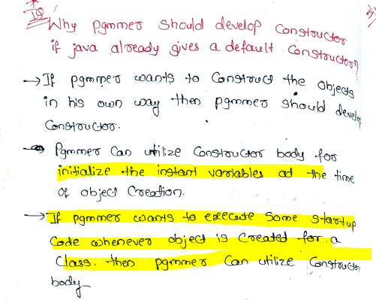

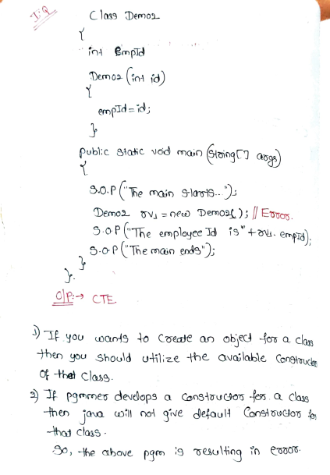

Good one:

One if parametrized constructor, otherone is no args const(Non parametrized constru)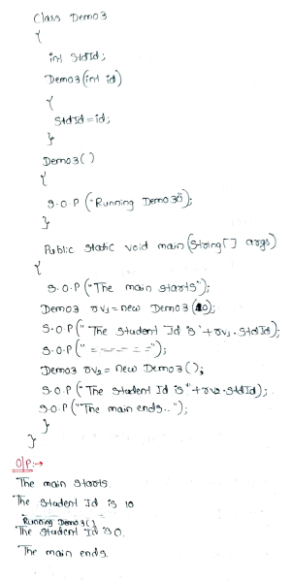

Invoking constructors using multilevel inheritance:

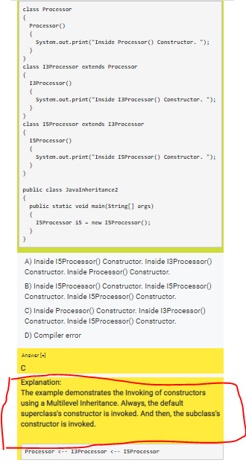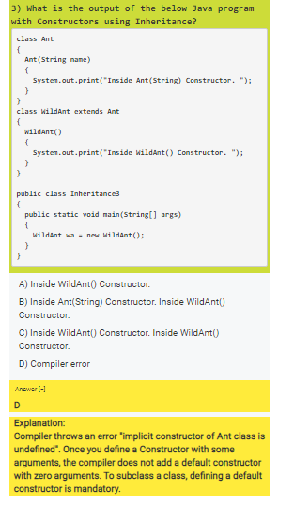

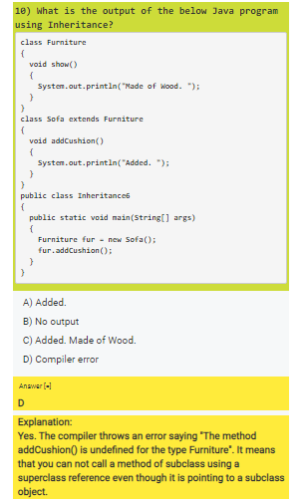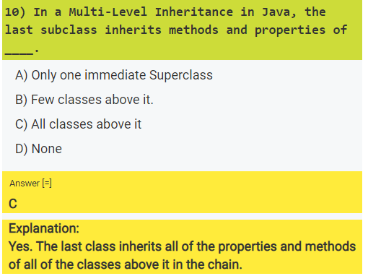

GoodOne:

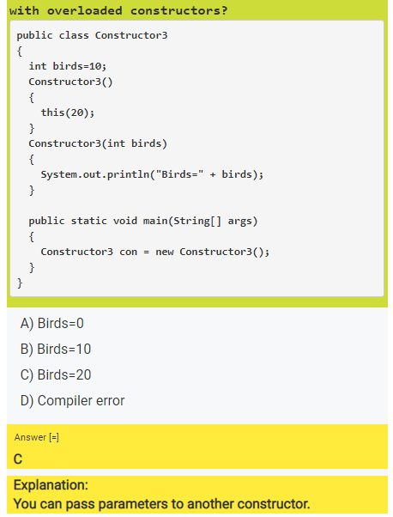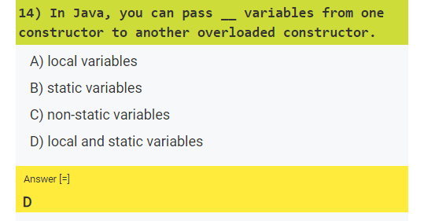

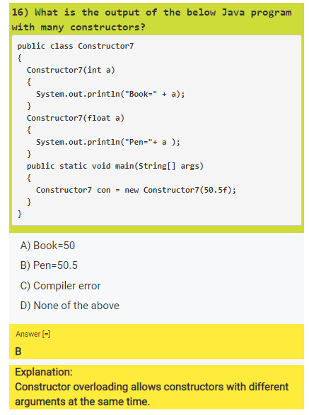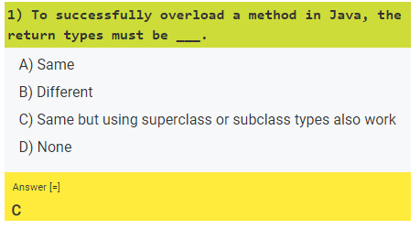

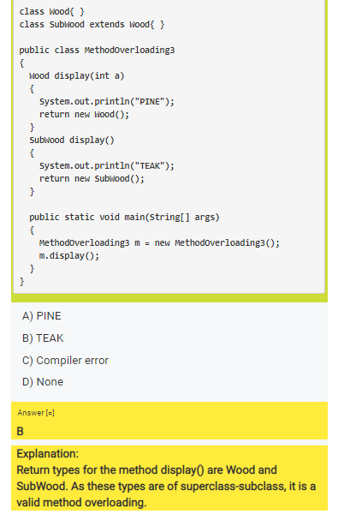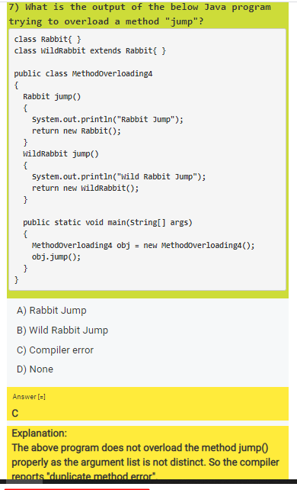

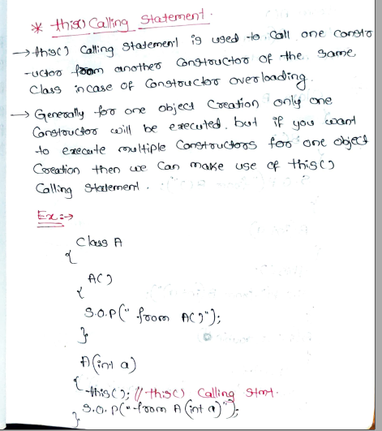

Static initialization block:

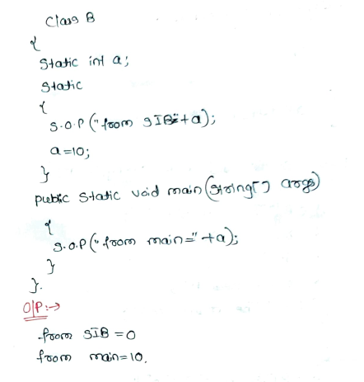

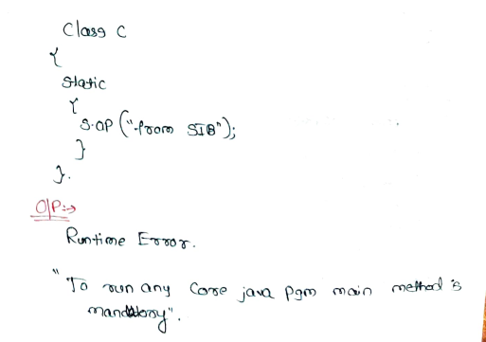

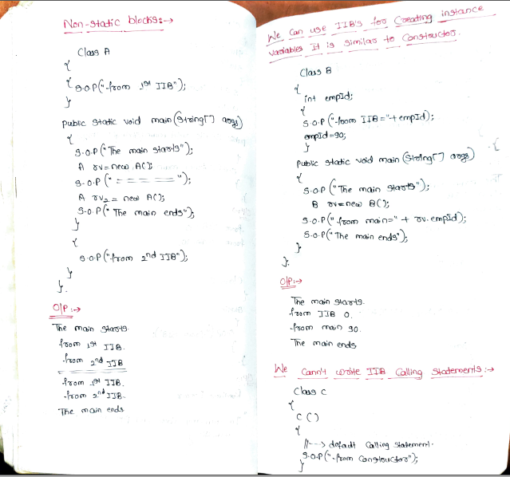

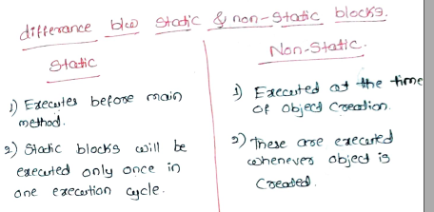

Post Increment:

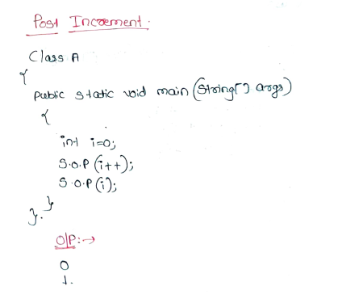

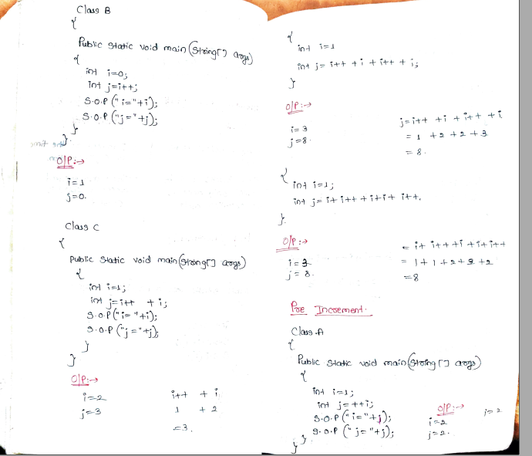

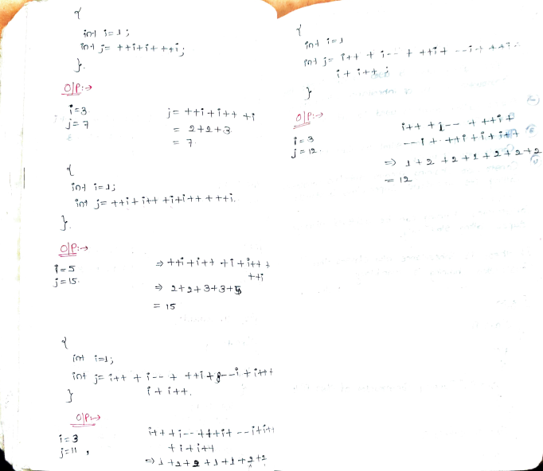

Constructor Chaining:

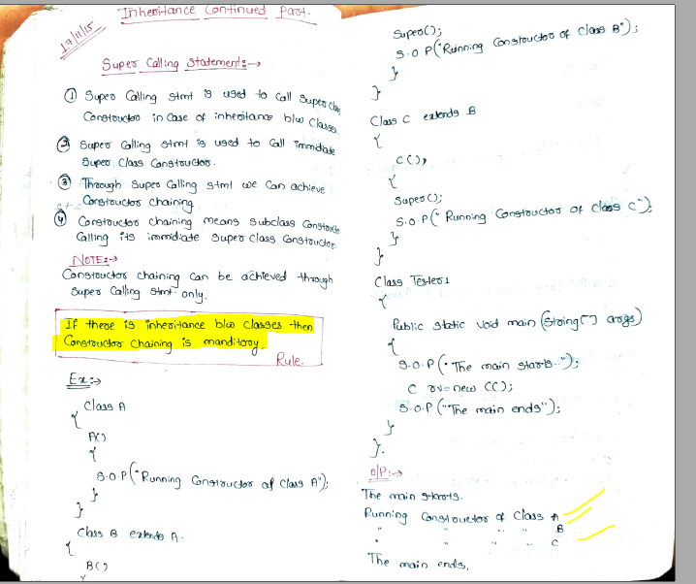

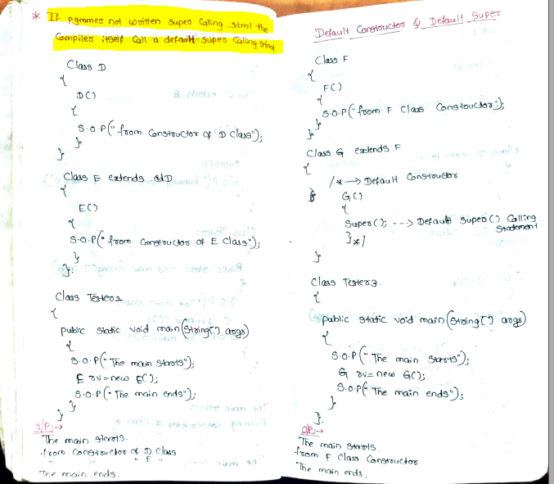

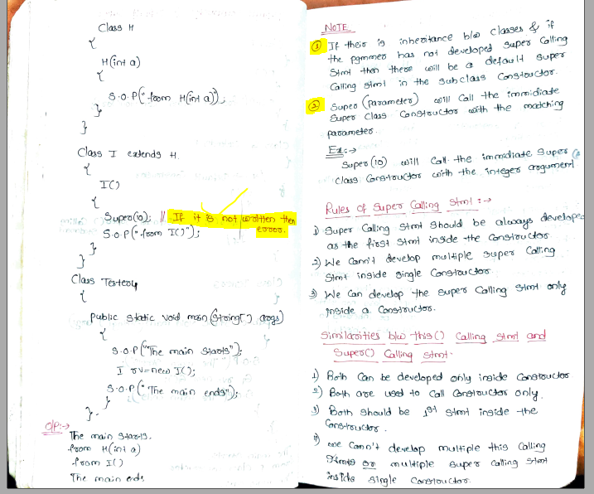

Observer below program for constructor chaining:

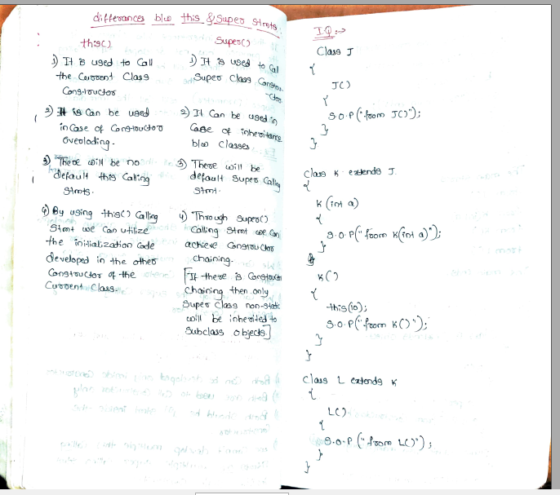

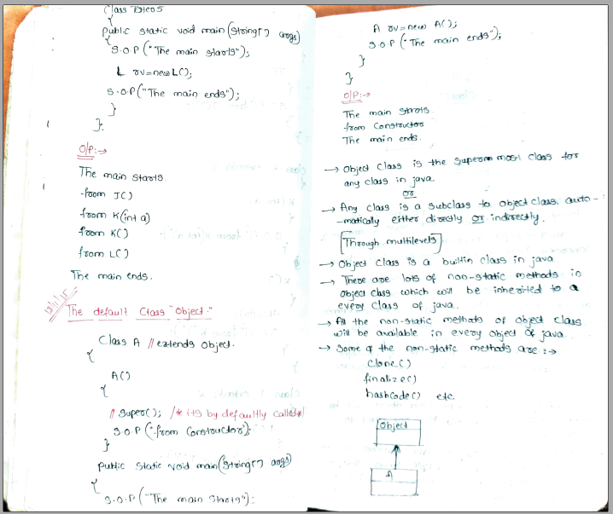

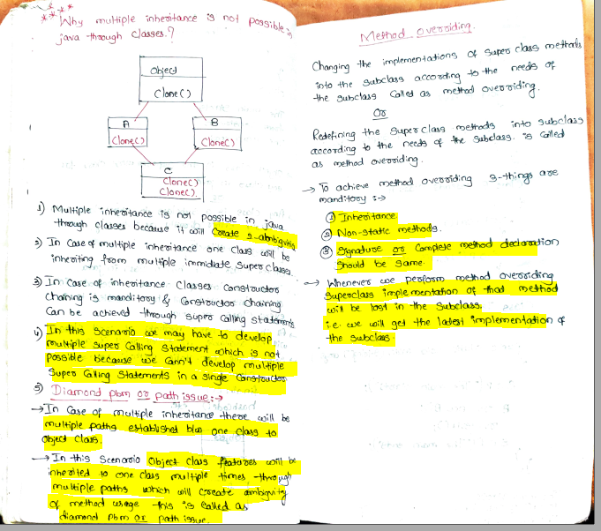

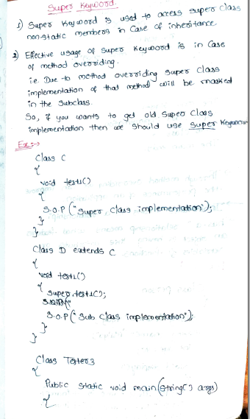

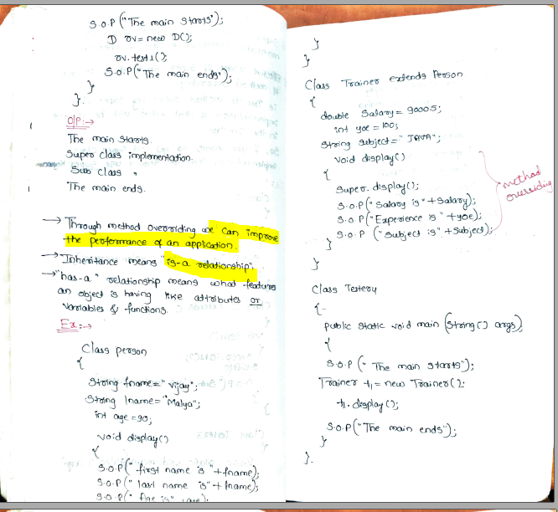

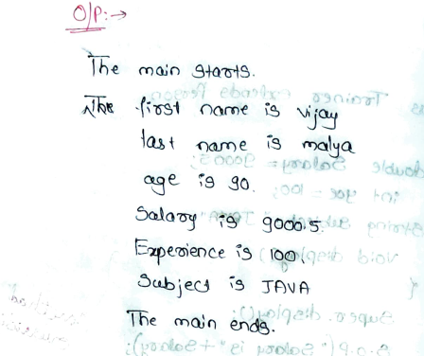

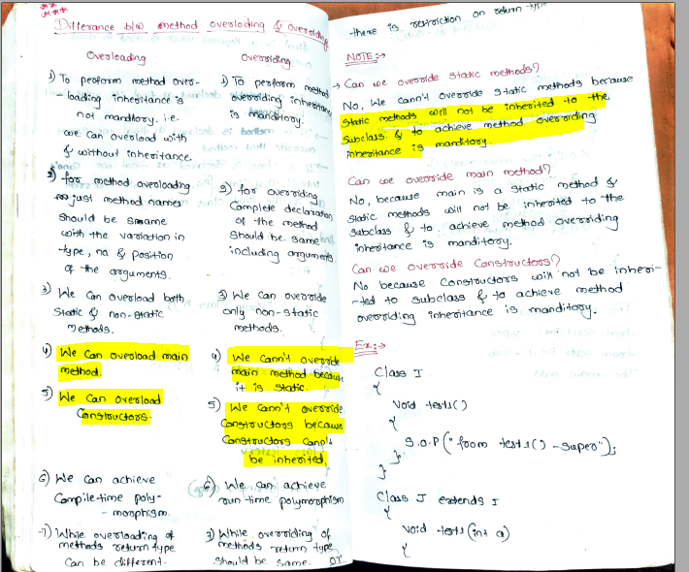

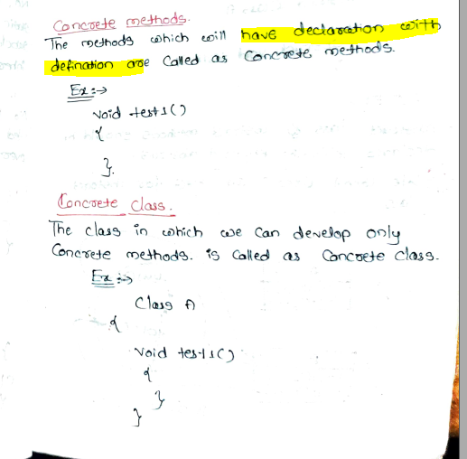

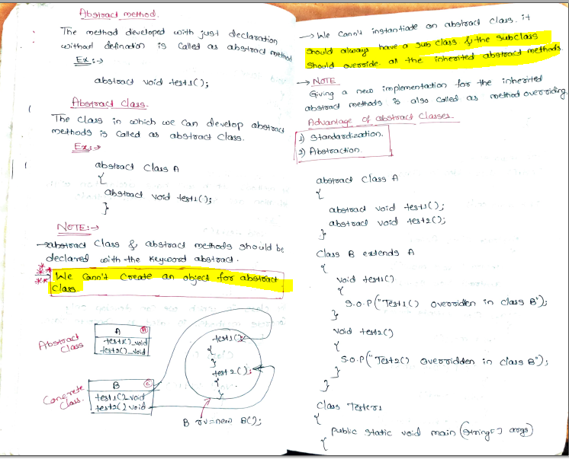

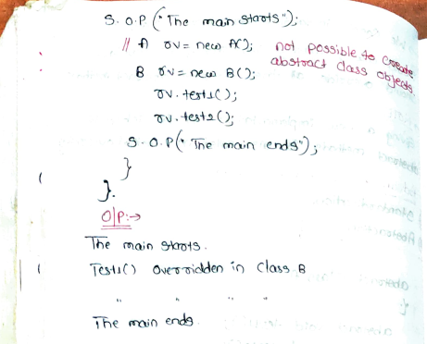

Abstract Class:

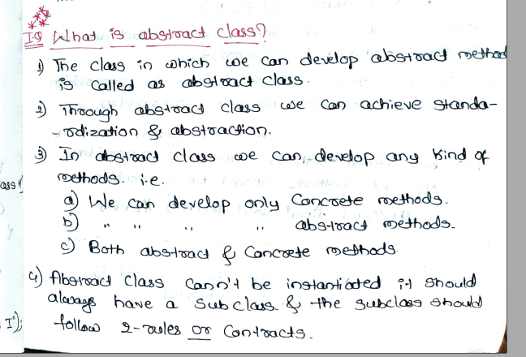

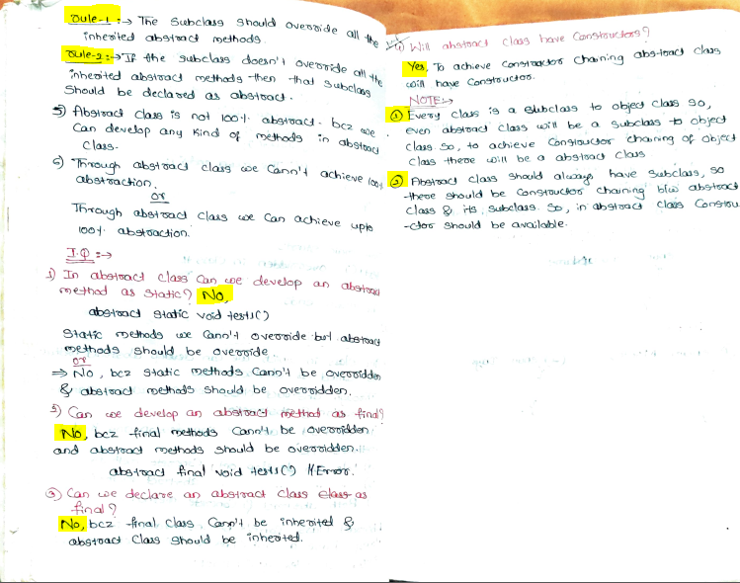

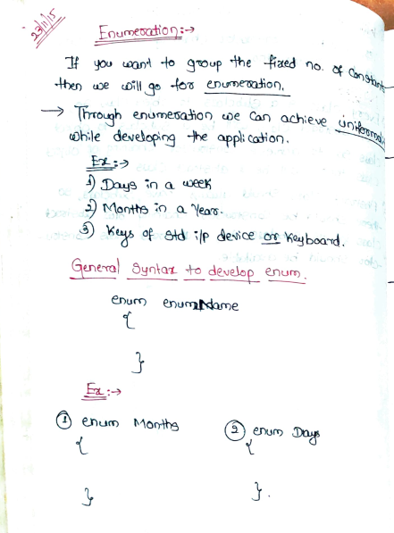

Interfaces:

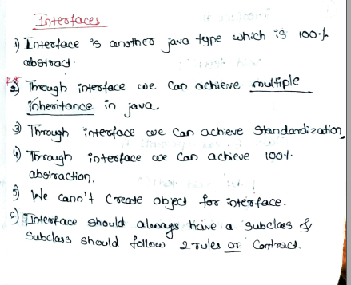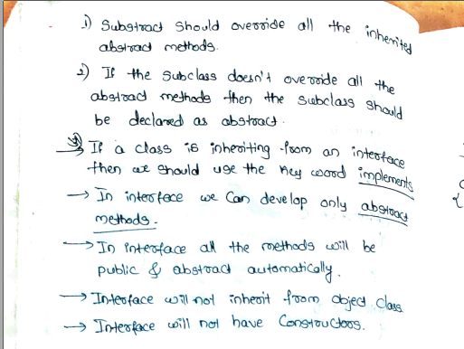

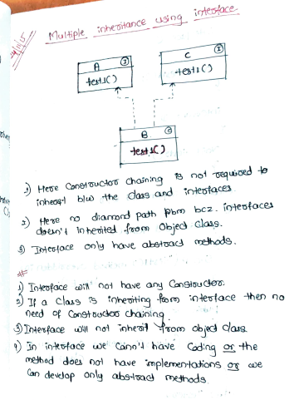

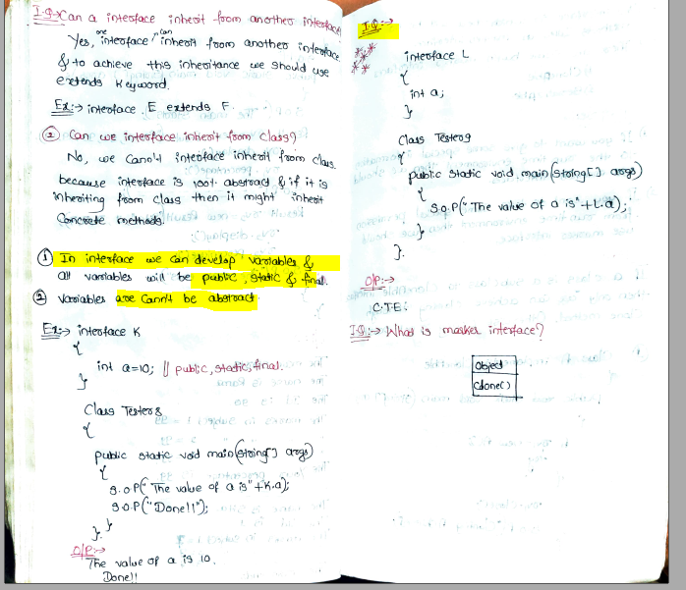

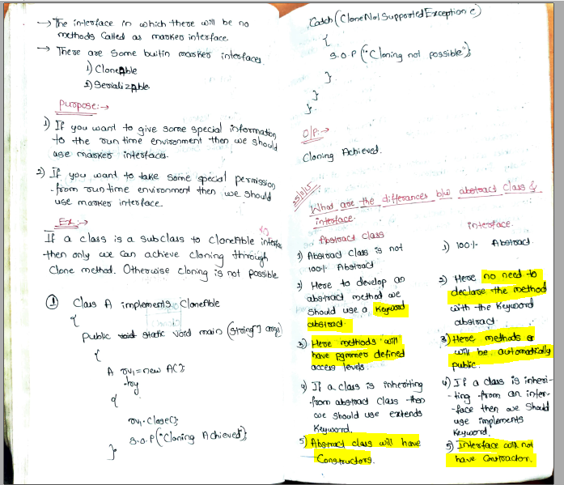

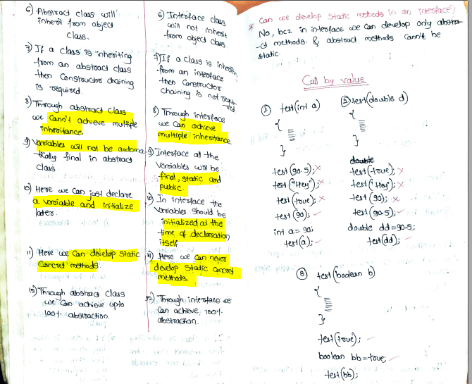

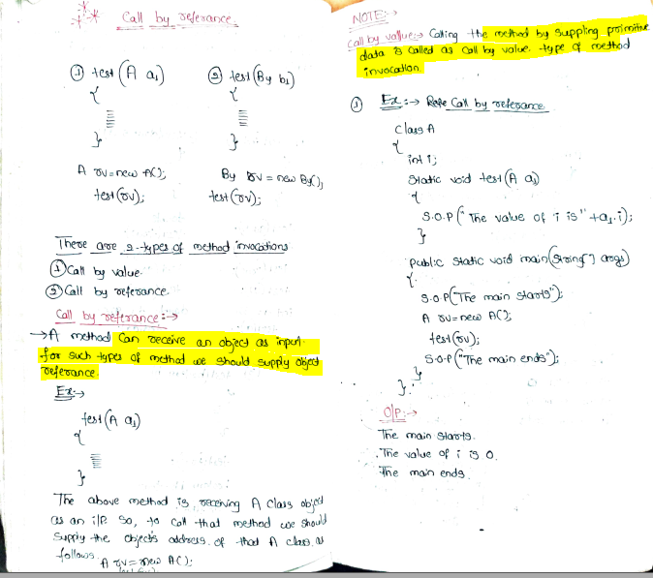

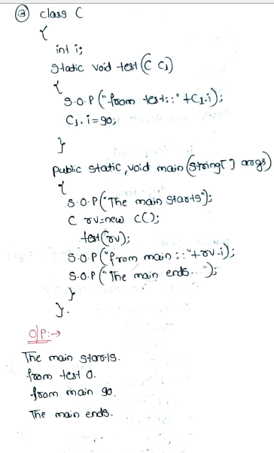

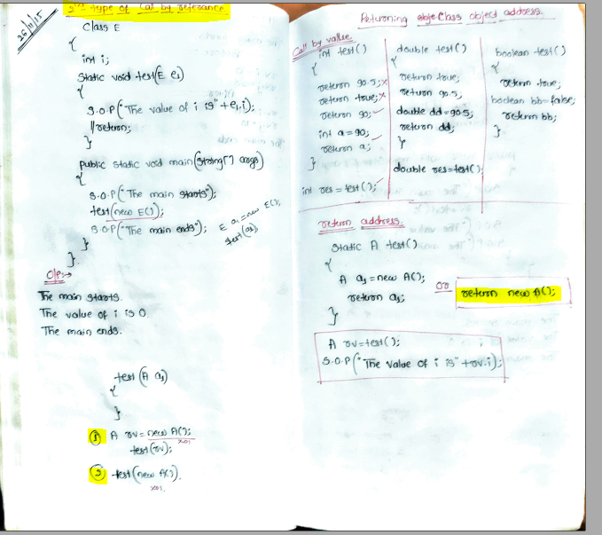

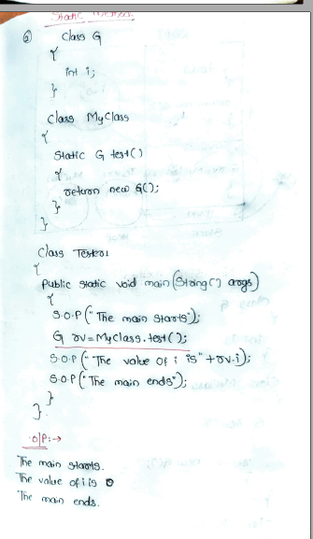

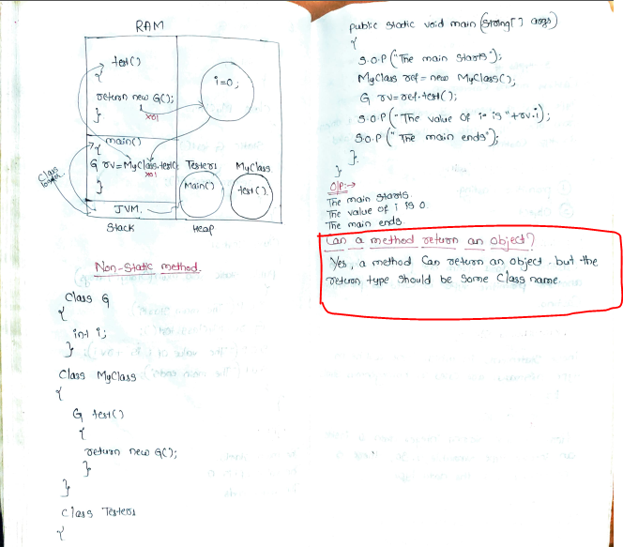

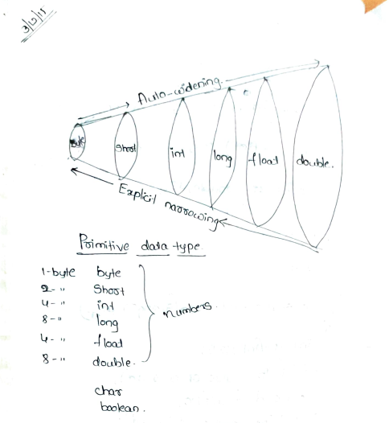

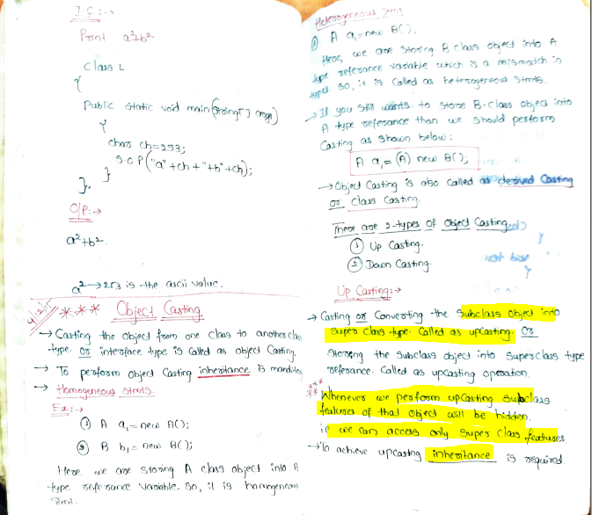

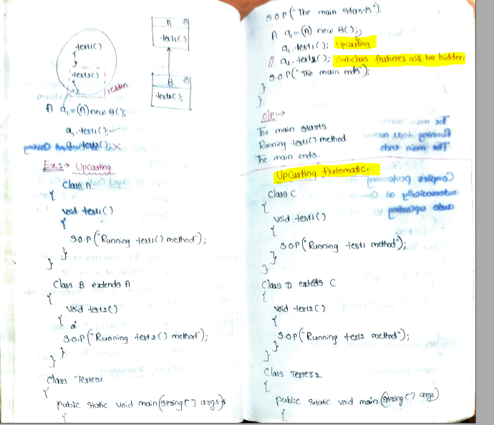

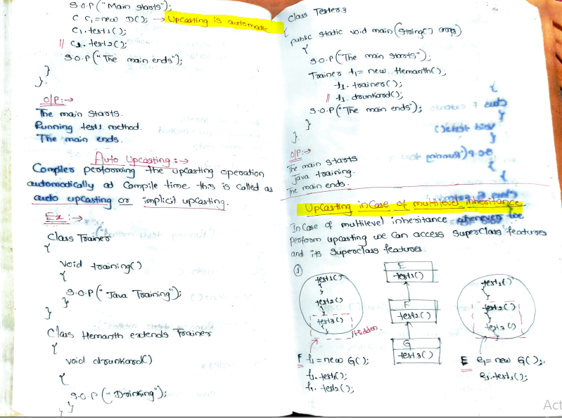

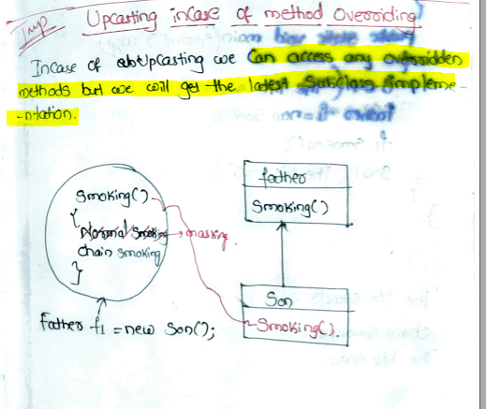

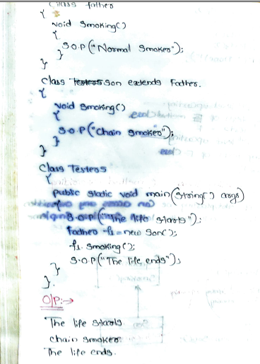

# Difference between Hashmap and Hashtable:

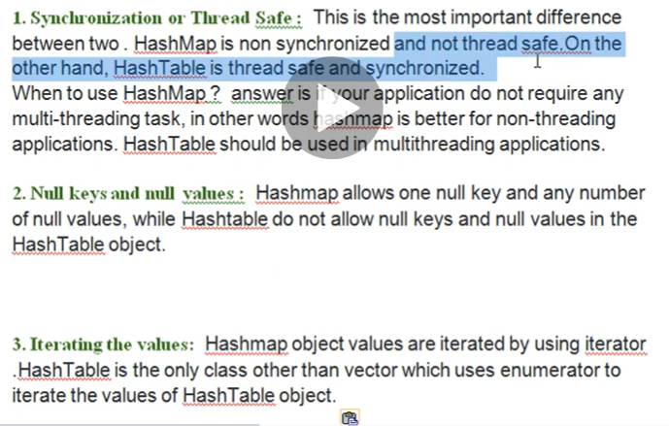

# Linked list:

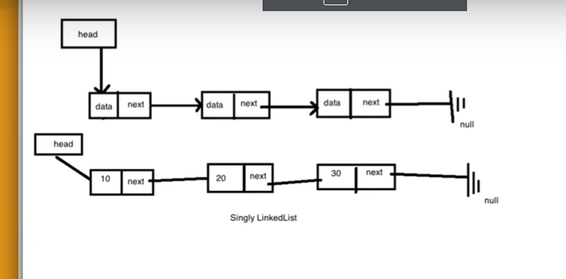

~~~Singly Linked Lists are a type of data structure. It is a type of list. In a singly linked list **each node in the list stores the contents of the node and a pointer or reference to the next node in the list**. It does not store any pointer or reference to the previous node. It is called a singly linked list because each node only has a single link to another node. To store a single linked list, you only need to store a reference or pointer to the first node in that list. **The last node has a pointer to nothingness to indicate that it is the last node.**

**Creation and Insertion**

In this article**, insertion in the list is done at the end**, that is the new node is added after the last node of the given Linked List. For example, if the given Linked List is 5->10->15->20->25 and 30 is to be inserted, then the Linked List becomes 5->10->15->20->25->30.   
Since a Linked List is typically represented by the head pointer of it, i**t is required to traverse the list till the last node and then change the next to last node to the new node.**

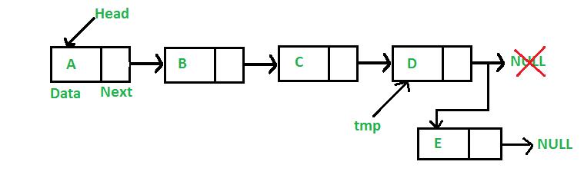

**Deletion By KEY**

The deletion process can be understood as follows:

**To be done:**

*Given a ‘key’, delete the first occurrence of this key in the linked list*.

**How to do it:**

To delete a node from the linked list, do following steps.

1. Search the key for its first occurrence in the list
2. Now, Any of the 3 conditions can be there:
   * **Case 1: The key is found at the** **head**
     1. In this case, **Change the head of the node to the next node of the current head.**
     2. Free the memory of the replaced head node.
   * **Case 2: The key is found in the middle or last, except at the** **head**
     1. In this case, **Find the previous node of the node to be deleted**.
     2. **Change the next the previous node to the next node of the current node**.
     3. Free the memory of the replaced node.
   * **Case 3: The key is not found in the list**
     1. In this case, No operation needs to be done.

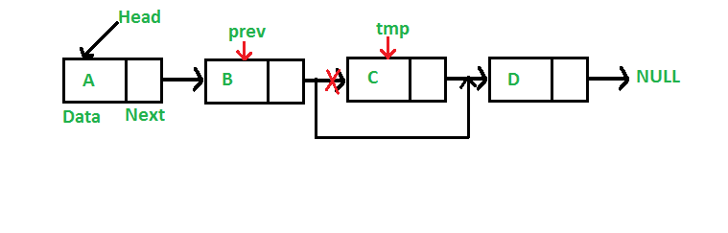

[**https://www.geeksforgeeks.org/implementing-a-linked-list-in-java-using-class/**](https://www.geeksforgeeks.org/implementing-a-linked-list-in-java-using-class/)

Own custom implementation of linkedlist:

[#18 - Introduction to LinkedList || Implementation of LinkedList in Java - YouTube](https://www.youtube.com/watch?v=GuWfBcxES44&list=PLFGoYjJG_fqoDQHufg7XVk-yb2w6CNpgF&index=18)

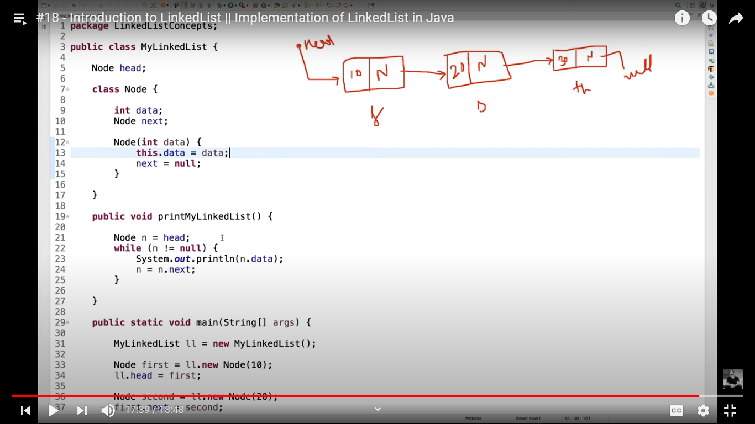

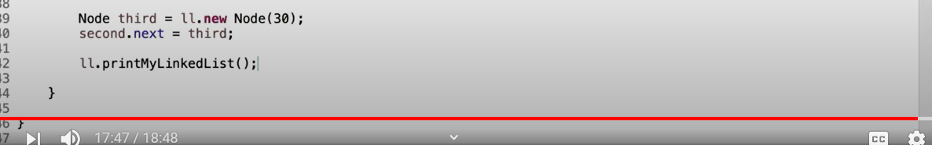

# Collections Framework

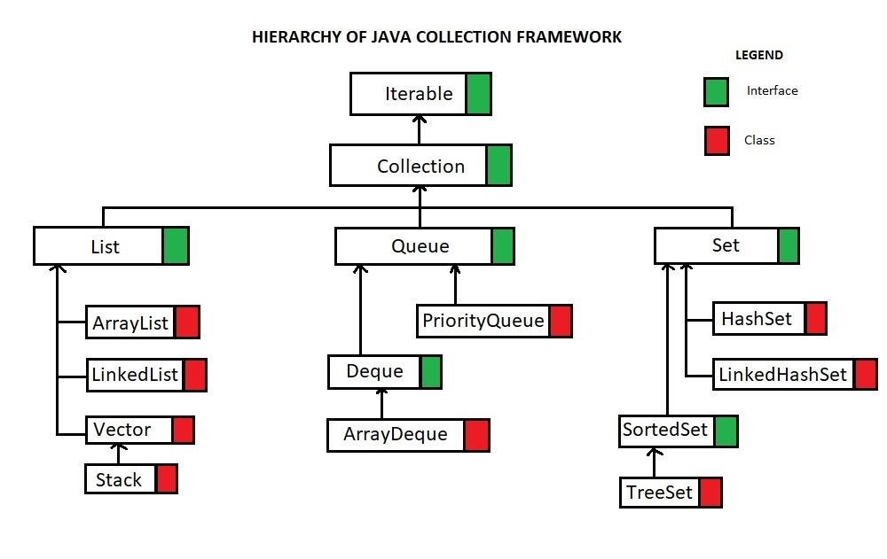

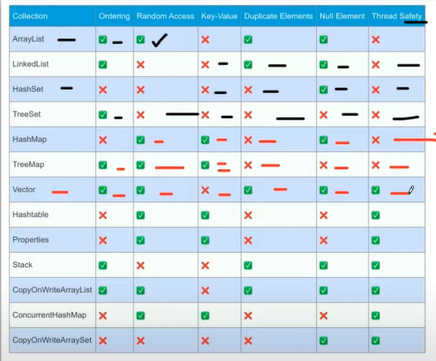

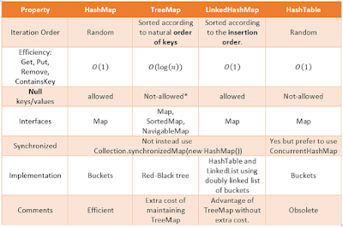

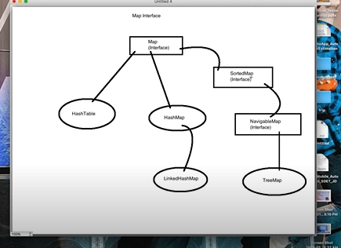

1. We can use == operators for reference comparison (**address comparison**) and .equals() method for **content comparison**. In simple words, == checks if both objects point to the same memory location whereas .equals() evaluates to the comparison of values in the objects.
2. If a class does not [override the equals method](https://www.geeksforgeeks.org/overriding-equals-method-in-java/), then by default it uses equals(Object o) method of the closest parent class that has overridden this method. See [this](https://www.geeksforgeeks.org/override-equalsobject-hashcode-method/)for detail

More at <https://www.geeksforgeeks.org/difference-equals-method-java/>

Stack and Heap: Memory Management In Java:

Heap Memory-

# How hashmap works internally?

<https://www.geeksforgeeks.org/internal-working-of-hashmap-java/>

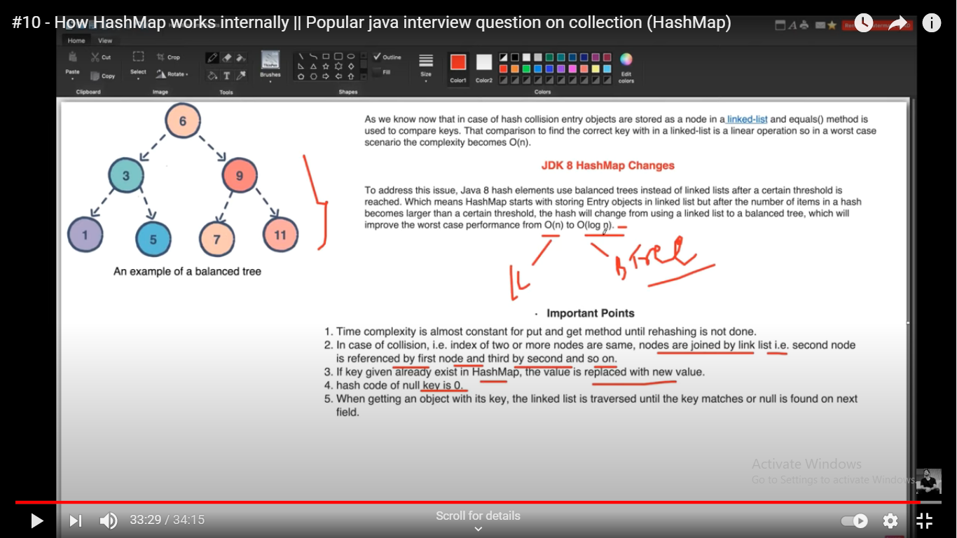

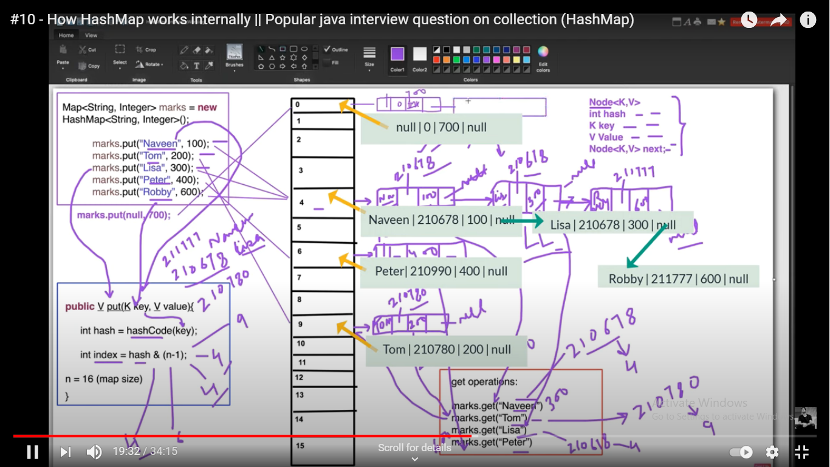

We Can visualize the hash and index assignment During debugging.

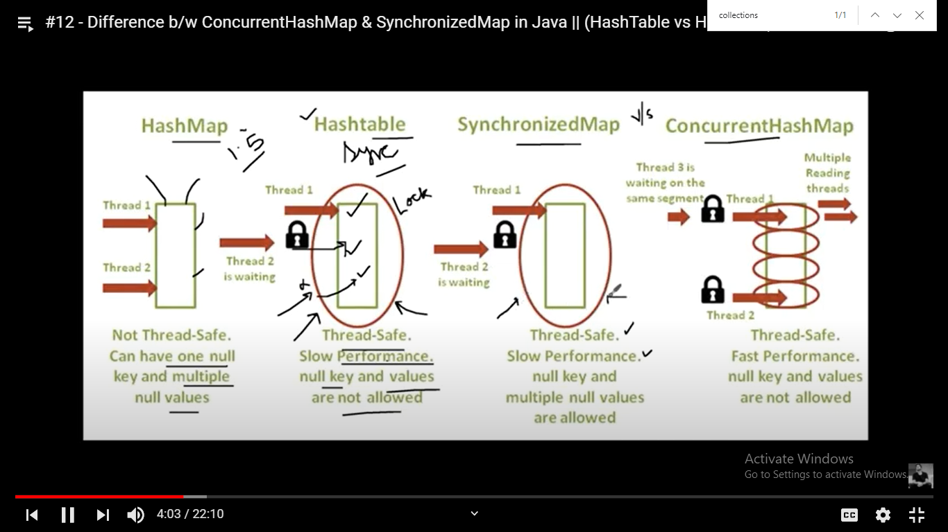

# How to make arraylist Synchronised:

1.Using collections.synchronised method

2.Using CopyonwriteArrayList class

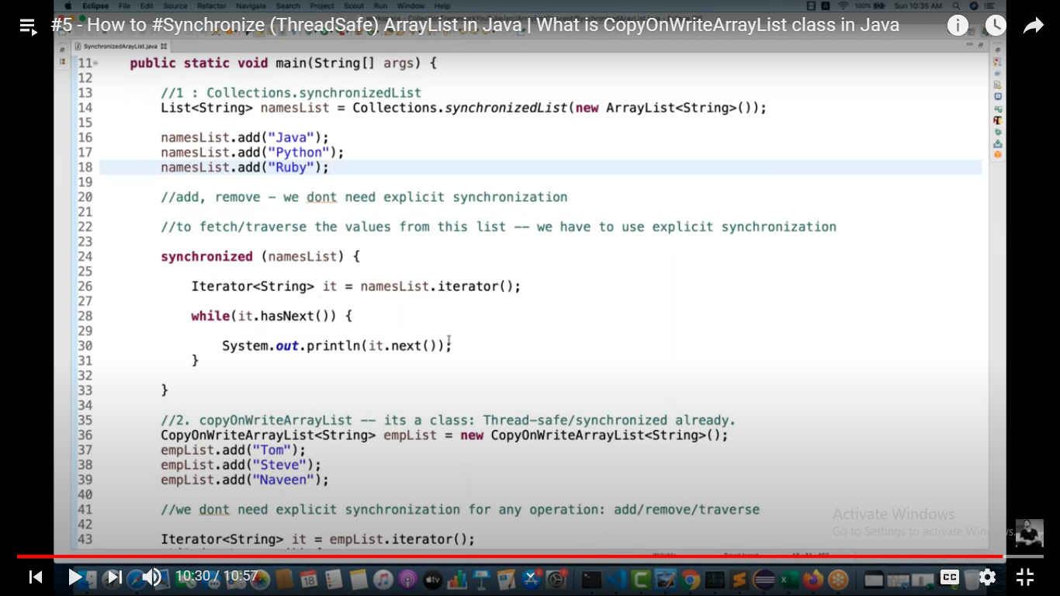

Treemap:

Implementation works on **Red-Black Tree**:

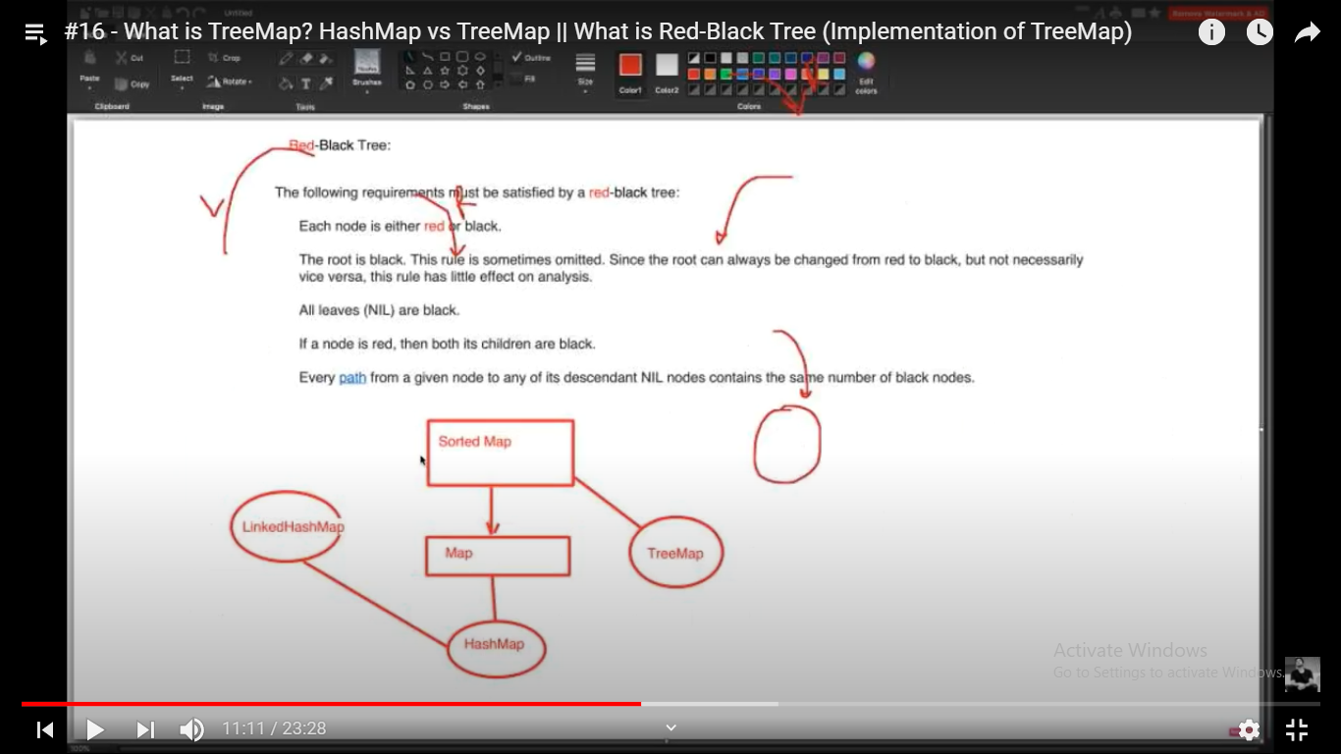

Exp implementing red black tree:

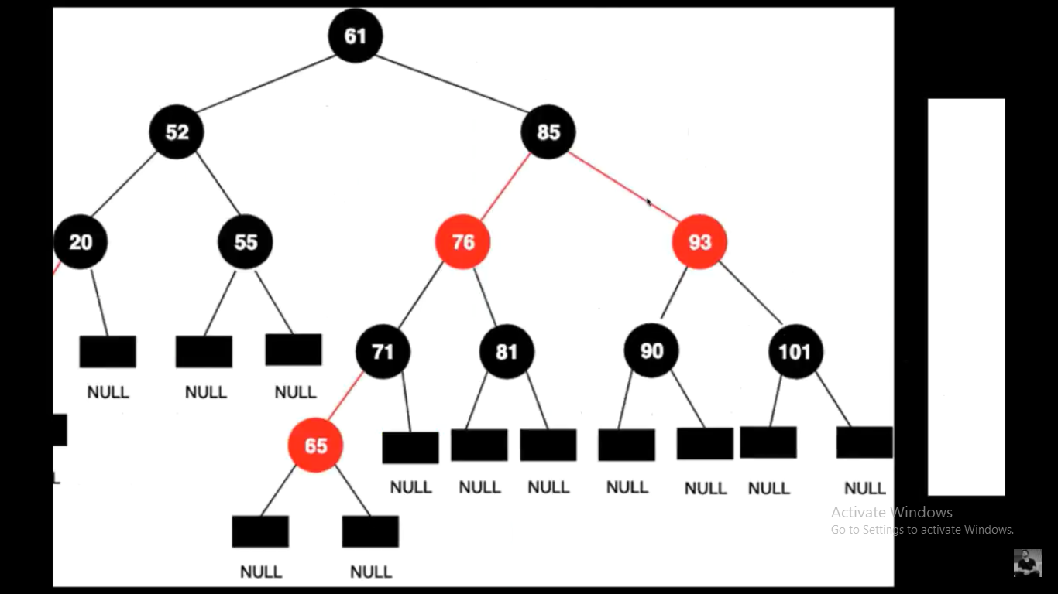

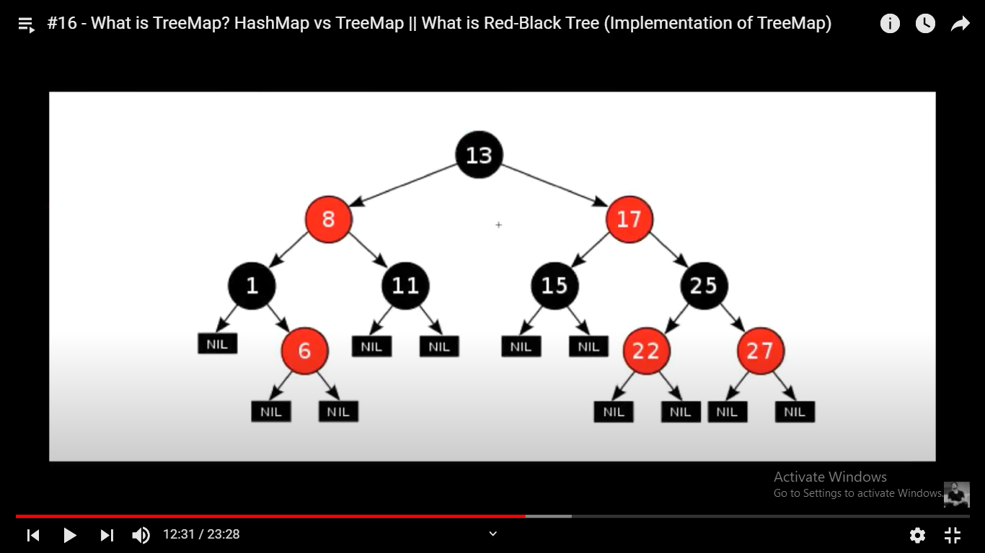

Practical example:

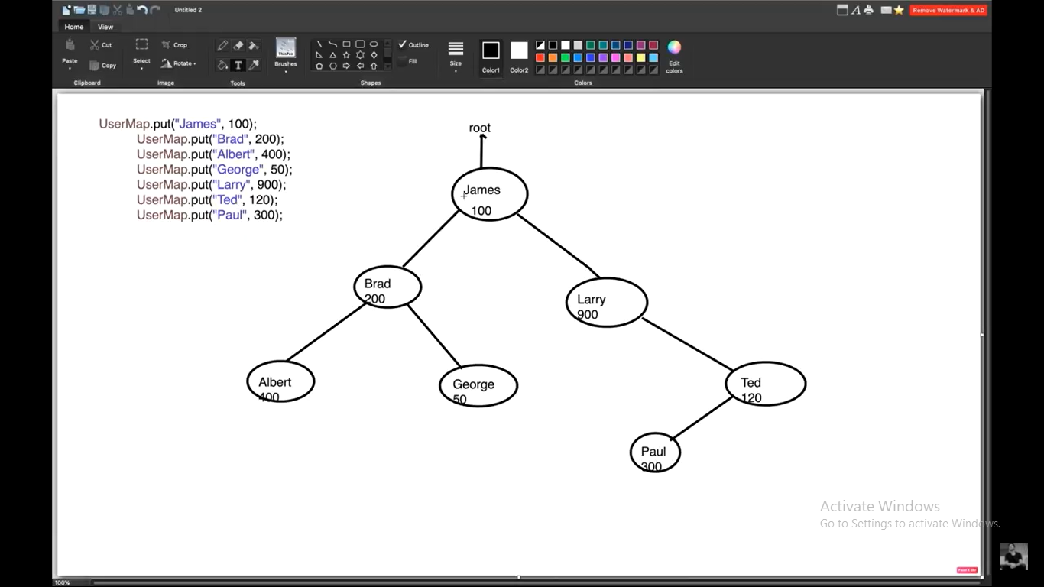

# Hash Table internal Working:

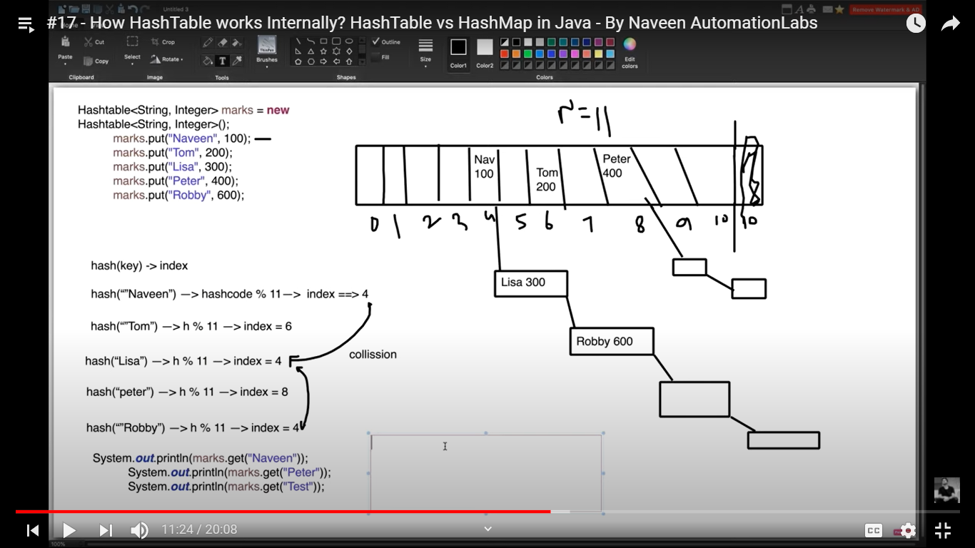

Set in collections:

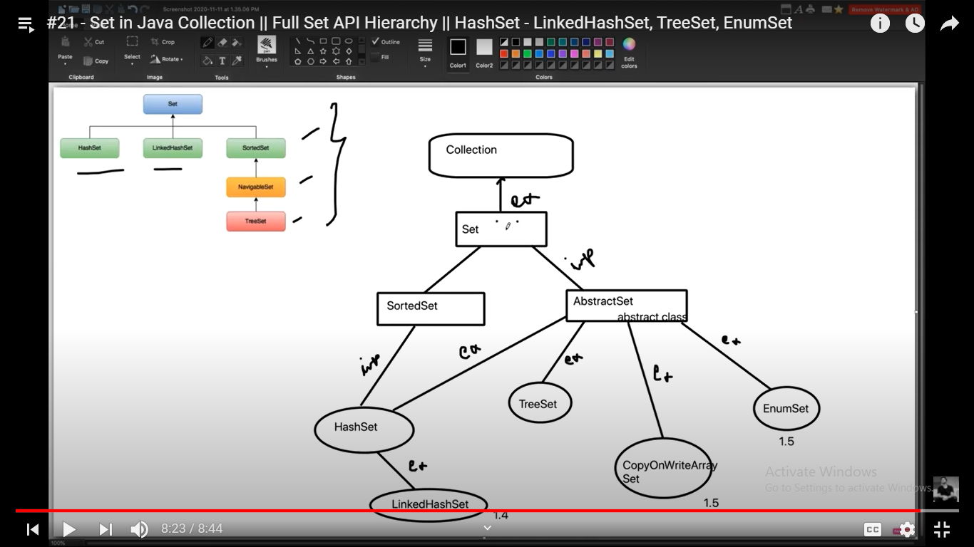

# Internal working of HashSet:

[java.util: HashSet.java (docjar.com)](http://www.docjar.com/html/api/java/util/HashSet.java.html) is the official documentation.

It internally implements hashmap only.It has 4 types of constructors see below.

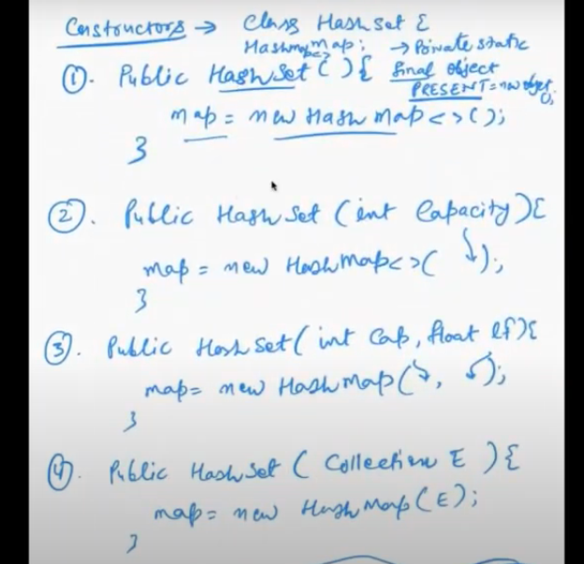

1.

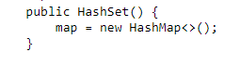

2.

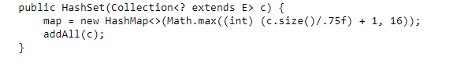

3.

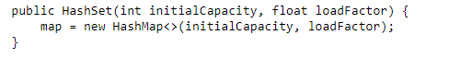

4.

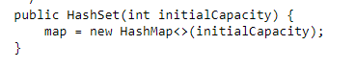

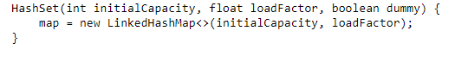

# Ex of how add and remove methods work:

The value will be constant “Present” for all whereas it changes for hashmap.

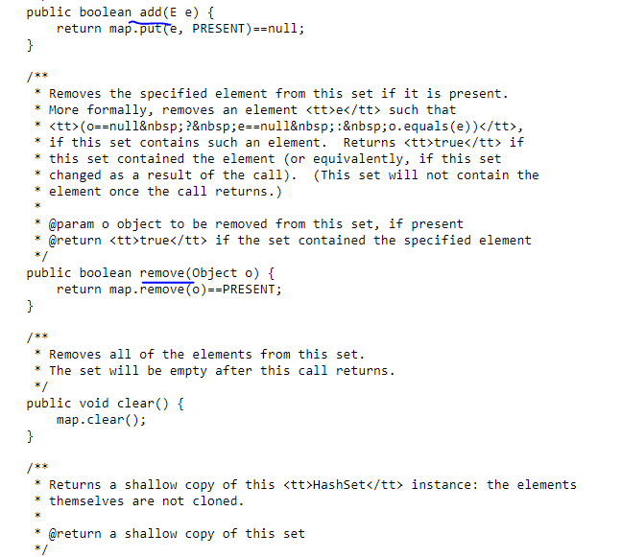

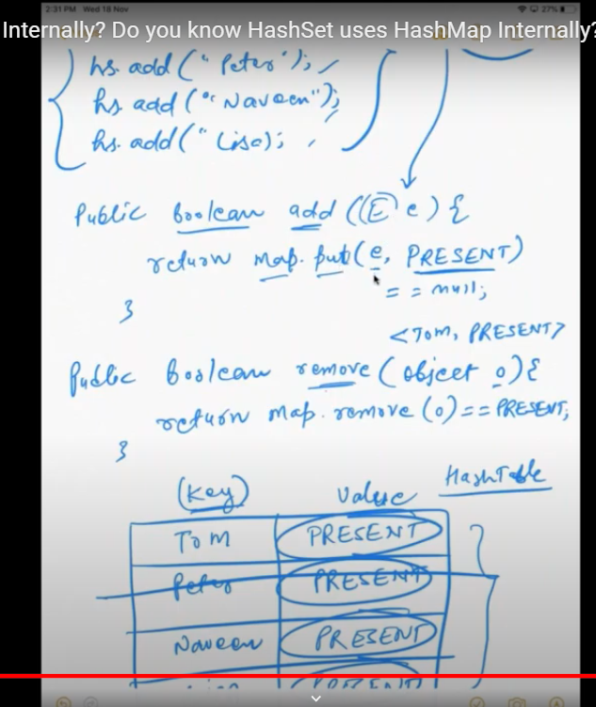

# Implementation of stack using array:

<https://www.geeksforgeeks.org/stack-data-structure-introduction-program/>

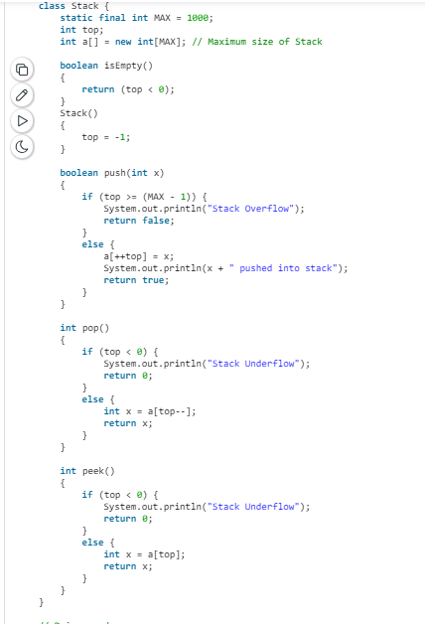

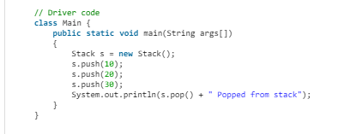

Above logic I did not try to understand but below logic is very simple.

Time complexity is O(1) since there is no for loop.

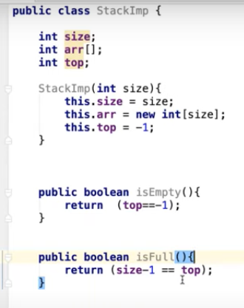

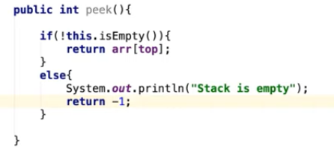

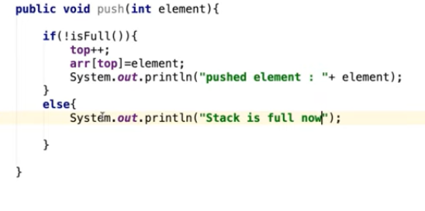

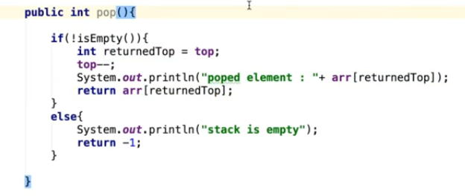

# Implementation of stack using linkedlist:

Good practice to store passwords in char array instead of string.

String is immutable and is displayed in console logs.

Char array will not be displayed in logs.

We can replace password with * in case of char array

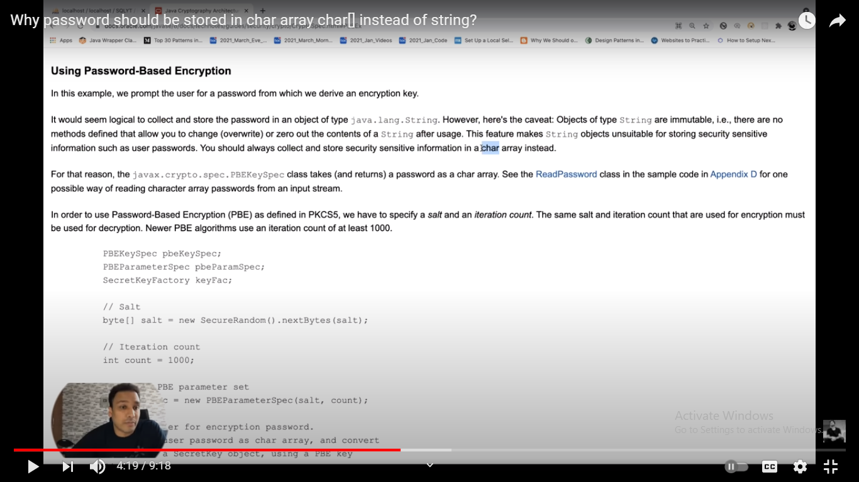

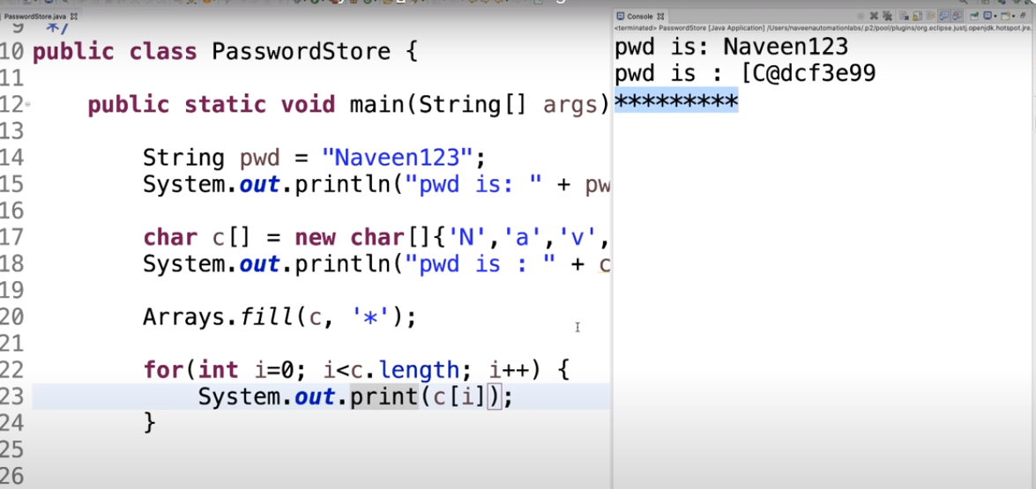

The **Java Regex** or Regular Expression is an API to define a pattern for searching or manipulating strings.

java.util.regex package

The Matcher and Pattern classes provide the facility of Java regular expression. The java.util.regex package provides following classes and interfaces for regular expressions.

1. MatchResult interface
2. Matcher class
3. Pattern class
4. PatternSyntaxException class

String reg exp meta chars:

|  |  |
| --- | --- |
| **Regex** | **Description** |
| . | Any character (may or may not match terminator) |
| \d | Any digits, short of [0-9] |
| \D | Any non-digit, short for [^0-9] |
| \s | Any whitespace character, short for [\t\n\x0B\f\r] |
| \S | Any non-whitespace character, short for [^\s] |
| \w | Any word character, short for [a-zA-Z_0-9] |
| \W | Any non-word character, short for [^\w] |
| \b | A word boundary |
| \B | A non word boundary |

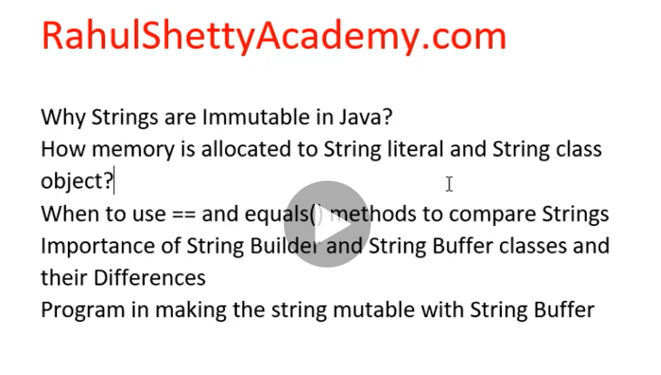

==: will compare the references

a.equals(b):this will compare content of a and b

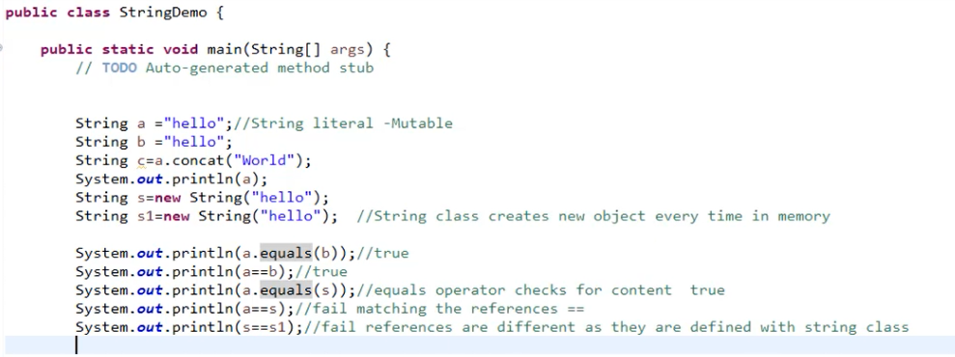

Java does not allow method duplicates:

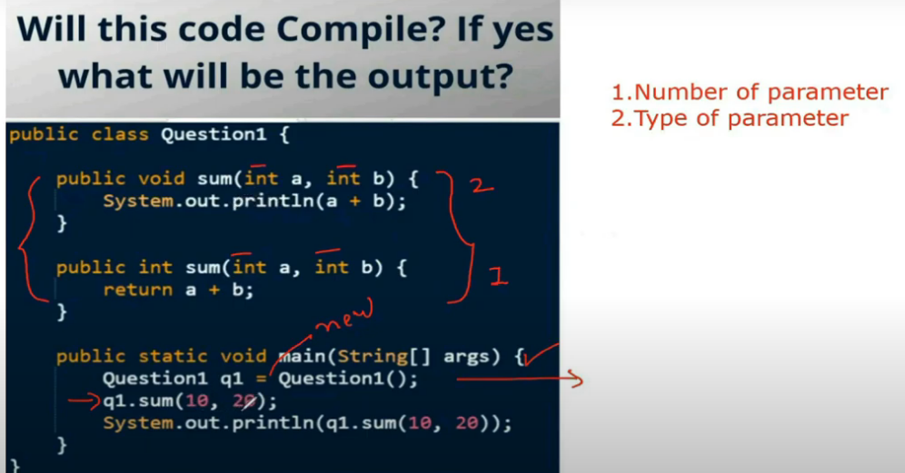

Drive method will execute without issues.But v.playmusic() gives compilation error as this is not present in vehicle class.

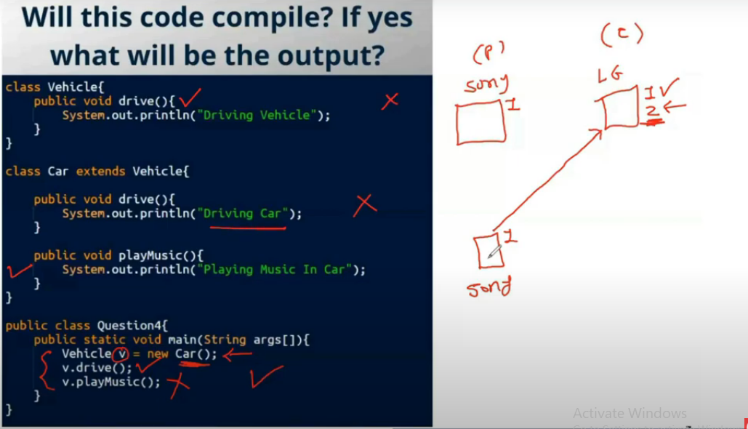

We cannot override static private final methods.We can not override variables.

v.drive()->op is “Driving vehicle” (this is static method so we cannot override.so parent method will be called)

v.race()-> op is “Driving at speed 180”.Here overriding happens and local instance variable will be printed.

v.maxSpeed->op is 200.Since we cannot override variables we get parent instance variable value only.

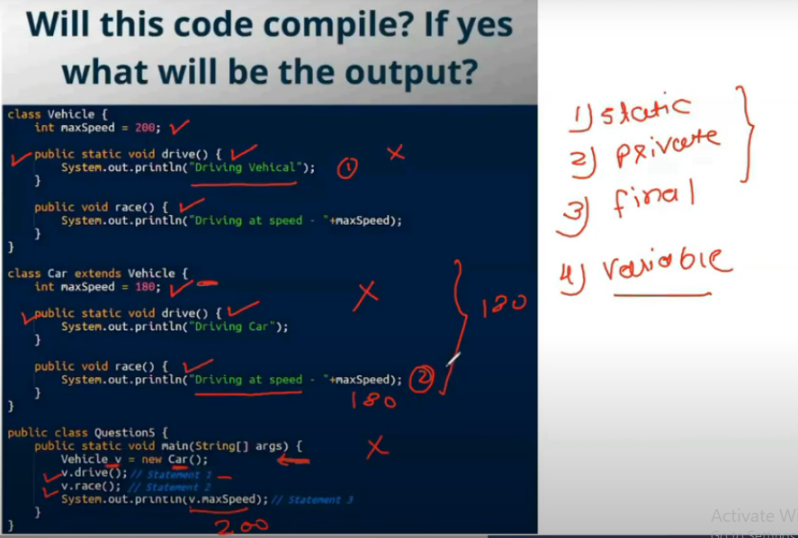

Gives compilation error**.Local variables cannot be static,abstract,we cant give access modifiers.**

**But we can give final.**

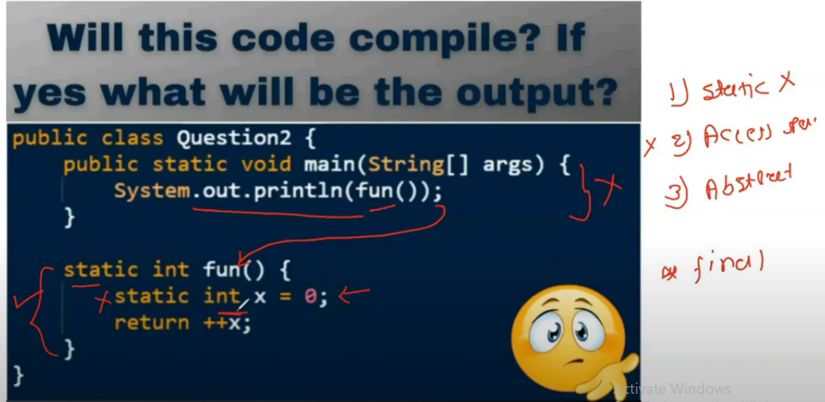

Gives compilation error as we are accessing local variable and it is not initiated.

Local variables must be initialized.

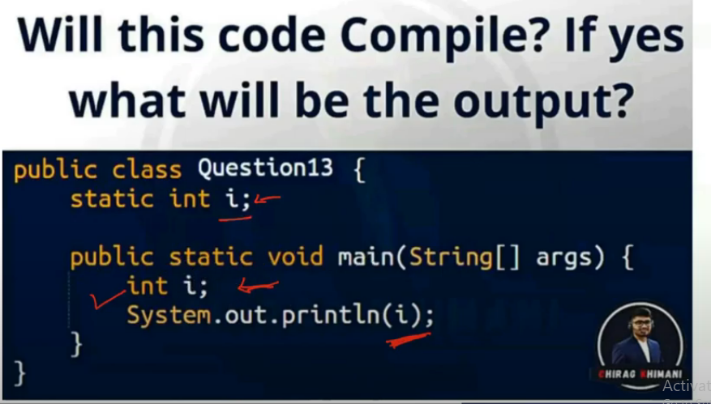

Switch statement does not support Boolean values

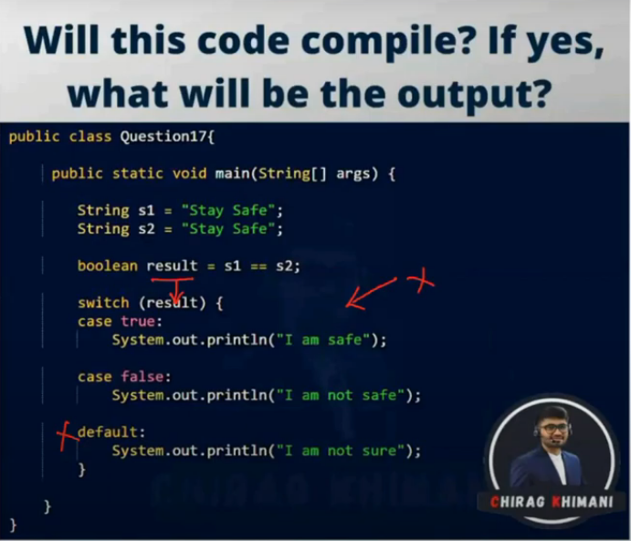

We are entering str2 during runtime so different memory location will be created.

Ans: False

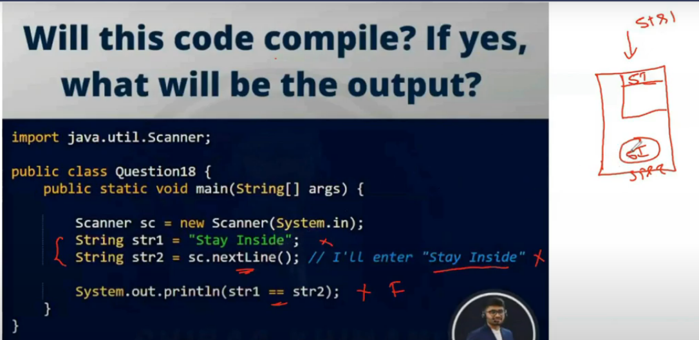

Line 1 and 4 gives error,Abstract class cant be instantiated.We cannot create obj for parent and assign to child reference.

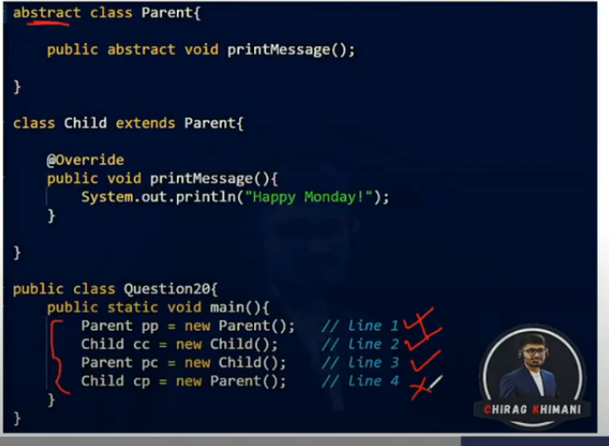

OOPS Interview questions

1. What are the core concepts of OOPS?

OOPS core concepts are;

* 1. Abstraction
  2. Encapsulation
  3. Polymorphism
  4. Inheritance
  5. Composition
  6. Association
  7. Aggregation

1. What is Abstraction?

Abstraction is an OOPS concept to construct the structure of the real world objects. During this construction only the general states and behaviors are taken and more specific states and behaviors are left aside for the implementers.

1. What is Encapsulation?

Encapsulation is an OOPS concept to create and define the permissions and restrictions of an object and its member variables and methods. A very simple example to explain the concept is to make the member variables of a class private and providing public getter and setter methods. Java provides four types of access level modifiers: public, protected, no modifier and private.

1. What is the difference between Abstraction and Encapsulation?
   1. “Program to interfaces, not implementations” is the principle for Abstraction and “Encapsulate what varies” is the OO principle for Encapsulation.
   2. Abstraction provides a general structure of a class and leaves the details for the implementers. Encapsulation is to create and define the permissions and restrictions of an object and its member variables and methods.
   3. Abstraction is implemented in Java using interface and abstract class while Encapsulation is implemented using four types of access level modifiers: public, protected, no modifier and private.
2. What is Polymorphism?

Polymorphism is the occurrence of something in various forms. Java supports various forms of polymorphism like polymorphic reference variables, polymorphic method, polymorphic return types and polymorphic argument types.

1. What is Inheritance?

A subclass can inherit the states and behaviors of it’s super class is known as inheritance.

1. What is multiple inheritance?

A child class inheriting states and behaviors from multiple parent classes is known as multiple inheritance.

1. What is the diamond problem in inheritance?

In case of multiple inheritance, suppose class A has two subclasses B and C, and a class D has two super classes B and C.If a method present in A is overridden by both B and C but not by D then from which class D will inherit that method B or C? This problem is known as diamond problem.

1. Why Java does not support multiple inheritance?

Java was designed to be a simple language and multiple inheritance introduces complexities like diamond problem. Inheriting states or behaviors from two different type of classes is a case which in reality very rare and it can be achieved easily through an object association.

1. What is Static Binding and Dynamic Binding?

Static or early binding is resolved at compile time. Method overloading is an example of static binding.

Dynamic or late or virtual binding is resolved at run time. Method overriding is an example of dynamic binding.

1. What is a Class?

A class is the specification or template of an object.

1. What is an Object?

Object is instance of class.

Java interview questions

#### What is Runtime Polymorphism?

Runtime polymorphism or dynamic method dispatch is a process in which a call to an overridden method is resolved at runtime rather than at compile-time.

In this process, an overridden method is called through the reference variable of a super class. The

#### What is the difference between abstraction and encapsulation?

Abstraction hides the implementation details whereas encapsulation wraps code and data into a single unit.

#### What is abstract class?

A class that is declared as abstract is known as abstract class. It needs to be extended and its method implemented. It cannot be instantiated.

#### Can there be any abstract method without abstract class?

No, if there is any abstract method in a class, that class must be abstract.

#### Can you use abstract and final both with a method?

No, because abstract method needs to be overridden whereas you can't override final method.

#### Is it possible to ****instantiate****the abstract class?

No, abstract class can never be instantiated.

**What is interface?**

Interface is a blueprint of a class that have static constants and abstract methods.It can be used to achieve fully abstraction and multiple inheritance.

 Can you declare an interface method static?

No, because methods of an interface is abstract by default, and static and abstract keywords can't be used together.

#### Can an Interface be final?

No, because its implementation is provided by another class.

#### What is marker interface?

An interface that have no data member and method is known as a marker interface.For example Serializable, Cloneable etc.

#### What is difference between abstract class and interface?

|  |  |
| --- | --- |
| **Abstract class** | **Interface** |
| 1)An abstract class can have method body (non-abstract methods). | Interface have only abstract methods. |
| 2)An abstract class can have instance variables. | An interface cannot have instance variables. |
| 3)An abstract class can have constructor. | Interface cannot have constructor. |
| 4)An abstract class can have static methods. | Interface cannot have static methods. |
| 5)You can extends one abstract class. | You can implement multiple interfaces. |

#### Can we define private and protected modifiers for variables in interfaces?

No, they are implicitly public.

#### When can an object reference be cast to an interface reference?

An object reference can be cast to an interface reference when the object implements the referenced interface.

# File separator:

In Java, we can use the following three methods to get the platform-independent file path separator.

1. System.getProperty("file.separator")

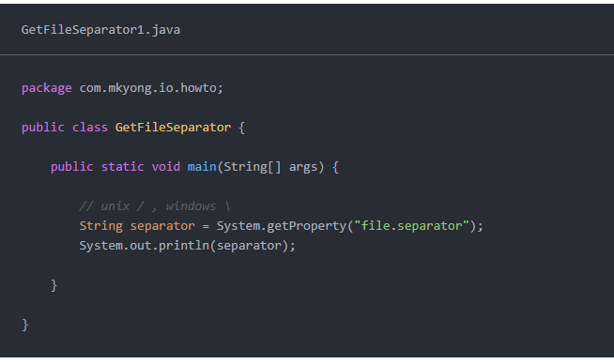

1. FileSystems.getDefault().getSeparator() (Java NIO)

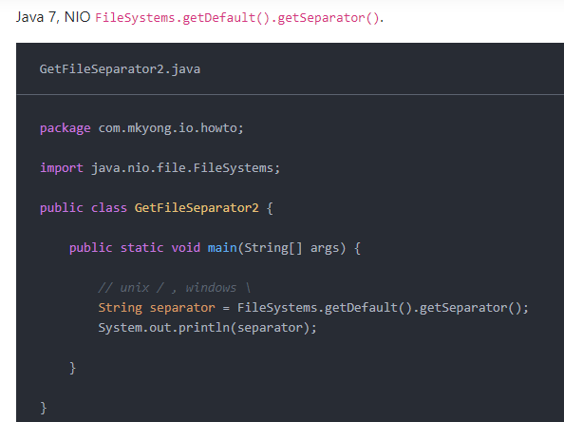

1. File.separator Java IO

